 Pollux Ibis Help

**1. Introduction**

**This document defines in detail the help for Pollux IBIS.**

The aim of the help file is to provide an introduction to the product. It contains easy explanations on how to use the tool,detail the functionality and at the same time provide the recommended procedures for performing the level of quality control using **IBIS.**

Best Practices, procedures, tips, Frequently asked questions (FAQ), glossary, troubleshooting, release notes and installation procedures, will be available on this help file.

Besides these pages, **IBIS** includes “pop up balloons” that explain the content or variables of the reports. The balloons are automatically displayed when hovering over the reports with the mouse pointer.

Row help: Direct link in any single row. It displays the meaning of the information on display.

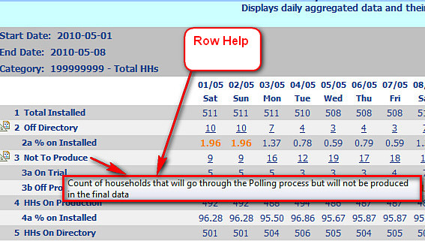

**Figure 1: Row Help**

Cell help: a simple tool tip or balloon appears while hovering over the report. It shows a short description or legend.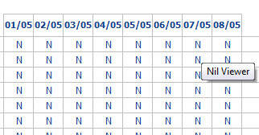

**Figure 2: Cell Help**

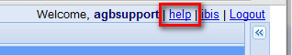

**Figure 3: Accessing Help pages**

This document is intended as a work in progress and should be modified as necessary to reflect the status of **IBIS.**

**2. What is IBIS?**

**Pollux Integrated Business Intelligence Suite (IBIS)** is a powerful platform to perform in-depth data analysis and quality control activities, providing a macro to micro view of the health of the panel. Users can navigate through reports easily with just a click of the mouse to drill down to deeper levels of data.

**IBIS** is a smart tool to reinforce the implementation of Nielsen’s Best Practices and Standard procedures worldwide. It should improve results as users will spend less time running reports and more time taking actions to improve quality and intab levels.

**IBIS** has been designed to replace the old PolluxCS reporting system.

Technically speaking **IBIS** incorporates.

• **SOA** (**S**ervice **O**riented **A**rchitecture).

• **AJAX** (**A**synchronous **J**avascript)  and **XML** (E**X**tensible **M**arkup **L**anguage).

• **ETL (E**xtract **T**ransform **L**oad**)** to transfer data from Pollux server to **IBIS Datawarehouse**

• **Data Warehouse**

• **OLAP** (**O**n**L**ine **A**nalytical **P**rocessing)

• **PostgreSQL** and **Tomcat** load balancing and clustering

Some benefits:

* It is a WEB application providing an easy, powerful and world wide accessible user interface.
* Support data navigation (drill down/through) - interactivity.
* Provides an enhanced data format and layout: conditional formatting, charts, text formatting.
* Provides security policies for data access: user trusting, user roles and data encryption.

**IBIS** has been designed to be a working tool through screen. Printing reports will eliminate all advantages introduced with the tool. Export to excel/PDF is not our recommended way of working. It should be used to share documents with those without login, e.g.external auditors, technical committees, JIC members, etc.

**3. Main Components**

**3.1 General Structure**

**IBIS** is composed by:

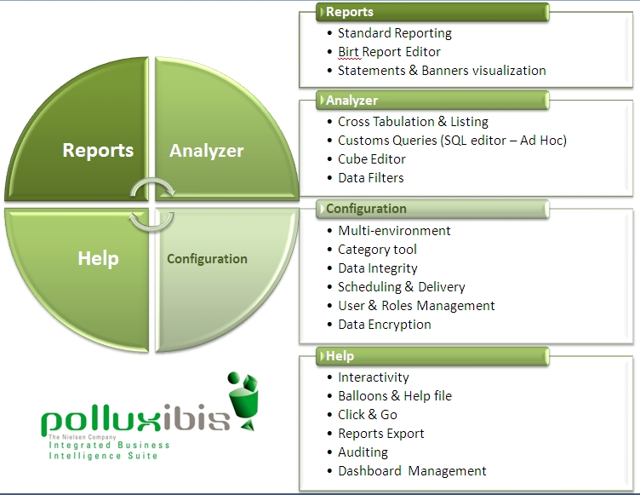

Currently, not all the elements for each **IBIS** component are fully developed. Please read release notes or this help file to fully explore the incorporated elements.

**3.2 Pollux IBIS - Report**

**Pollux IBIS - Report**: provides an easy wayto **create, customize** and **execute** reports**.**

It permits the implementation of new reports, based on an integrated and extensive Data Warehouse, suitable for XML, PDF and Excel export formats.

**Main tool:**

• Standard Report module – the reporting system: executes, interactively, pre-defined reports and permits to navigate through different reports and exports the result to excel and PDF.

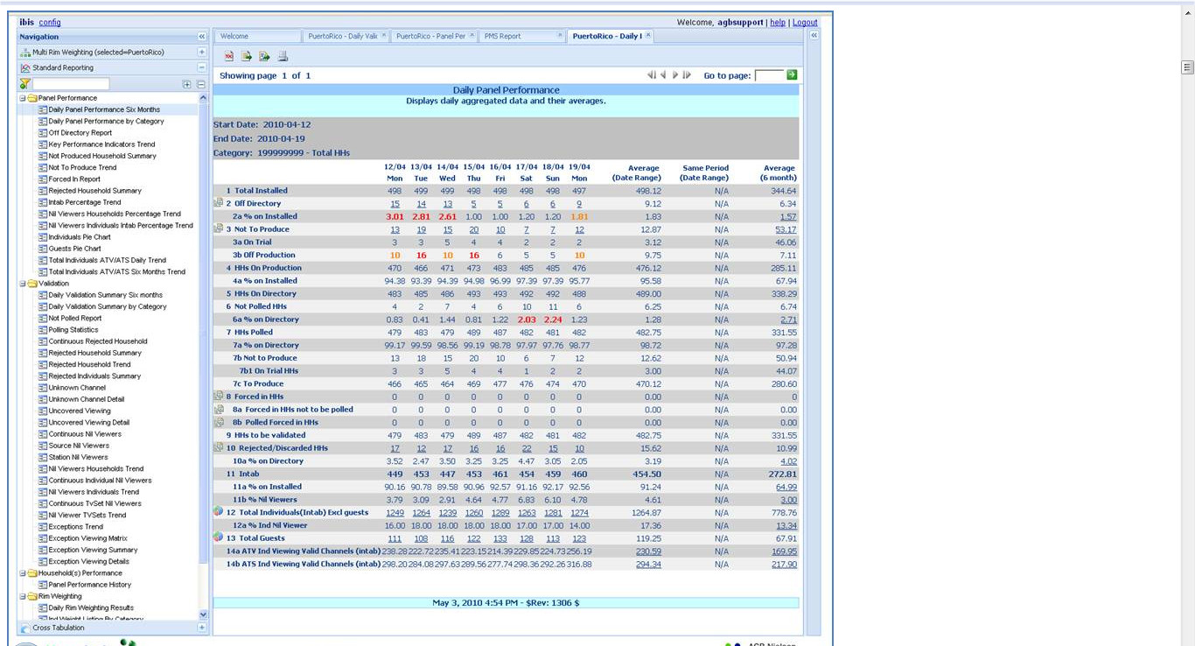

**Figure 1: Daily Panel Performance Report Main Page**

**3.3 How IBIS Report works**

**IBIS** Standard Report Module has been structured using 3 main elements: BIRT report designer, ETL process and Data Warehouse (DWH), that  when combined allows users to visualize organized information (interactively) through a web browser.

•     BIRT (Eclipse-based) is a system to develop reports for web applications (especially those based on Java - J2EE platform). Developing  skills are needed and a deep knowledge of the Data Warehouse structure.

•     All information required for the reports are gathered (daily) from Pollux Databases (PRO.gdb, Household Master File, File Maintenance,  meter statements, etc) and transferred to the Pollux Enterprise Data Warehouse using an ETL process.

•     The ETL process, stands for “Extract + Transform + Load”. Perhaps, the most important part of the process is the “transformation” as the system can be applied to data with a series of rules or functions so the data will meet the needs of the DWH or/and reports.

•      Pollux Data Warehouse is a storage or repository of information. designed to facilitate reporting and analysis.

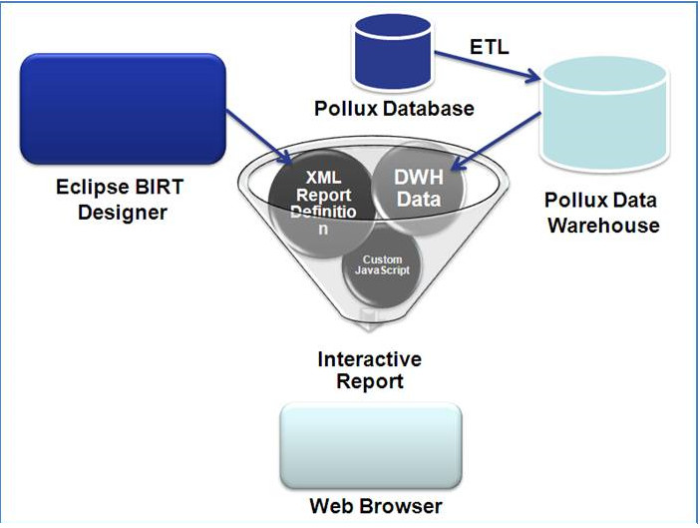

**Figure 1: How Ibis Works**

**3.4 How IBIS Analyzer works**

**IBIS Analyzer Module** has been structured around the ETL process to download the information from Pollux files and databases to **IBIS** Data Warehouse (DWH), to run queries in real time straight from the DWH to the web browser. These are “Ad Hoc” queries to investigate issues that are outside the day to day quality control procedures, therefore not present on the “standard reports”. The output will have a similar structure to a pivot table (for complex analysis) or a simple listing (flat table query).

Besides, there is the OLAP cube (Online analytical processing) which allows a fast interaction with the data.  The cube will contain *measures*   (numeric facts) which are categorized by dimensions.  The MDX (Multidimensional Expressions) which is the query/calculation language equivalent to a spreadsheet with formulas.

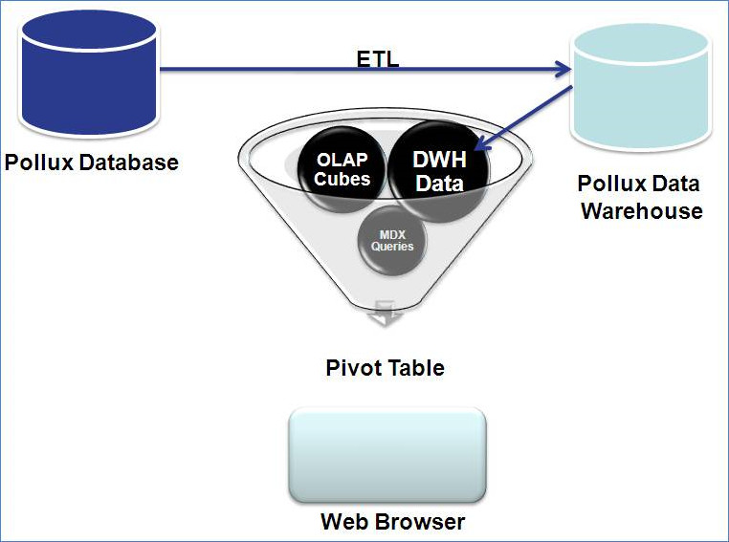

**Figure 1: How Analyzer Works**

**3.5 Extract-Transform-Load (ETL) Process**

ETL is the process that takes the information produced by the Pollux Server and uploads it into the Data Warehouse (database) where the information will be stored. During this process, some calculations or data transformations might take place not only to adjust to the new concepts available in IBIS but also to speed up the responsiveness of the reports (performance).

The first version of IBIS had an ETL process done in one single step. Depending on the panel size and the amount of historical information stored in HHMaster, the ETL process could take some hours.

Conscious of the criticality of the process some improvements have been introduced to remove the bottlenecks by dividing the **ETL on 6 steps**:

•        Step 1 - HHMaster: Extracting information from HHMaster to IBIS only those data that has changed. It runs at the end of PrePoll

•         Step 2 -  Preval: It runs at the end of PrePoll

•         Step 3 – Polling information (steps from 3 to 6 run at the end of PostPoll)

•         Step 4 – Validation results from validation process

•         Step 5 – Sector Viewing export of Validated & formatted data

•         Step 6 – Rim Weighting results

Additionally we have included a “**Daily automatic vacuuming and re-indexation**” process that should keep the Data Warehouse within a reasonable size as well as to reduce the incremental processing time we had experience on previous versions.

More improvements will be introduced on the next version. Please keep us inform if you experience any problems with the ETL process.

**4. Ibis Login**

**4.1 Ibis Login**

* Google Chrome internet browser is recommended for Pollux **IBIS.**
* **IBIS** IP address should be inserted at host file (c:\WINDOWS\system32\drivers\etc\hosts) to facilitate login process
* Example of an Ibis http address: <https://10.130.2.21/ibisanalytics/>  Each country will have their own address.

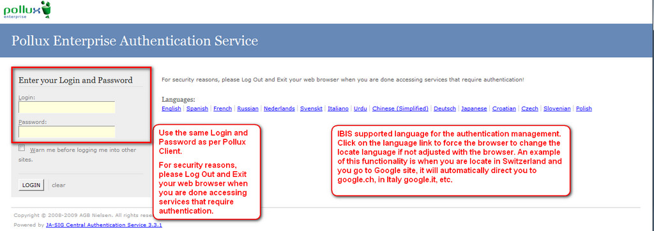

**Figure 1: Pollux Ibis Login**

**5. Windows Panel**

**5.1 Windows Panel**

**IBIS** dashboard is composed by 3 main areas:

* Left Panel: it is the “navigation” to access the different **IBIS** components (e.g, **IBIS** Report).
* Central Panel: it is the working area where the tools and reports will be displayed .
* Right Panel: where the report’s parameters are displayed and/or modified.

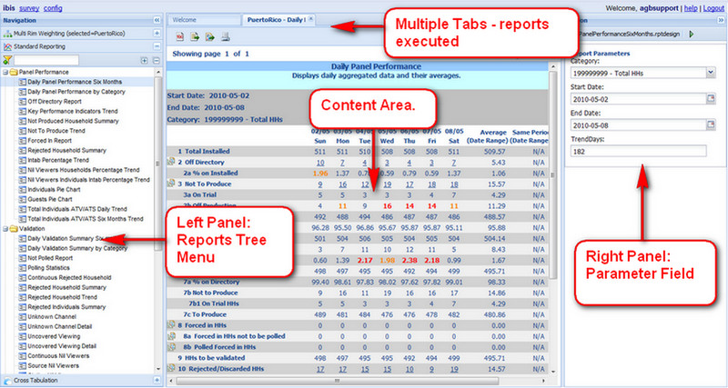

**Figure 1: Windows Main, Left and Right Panels**

**6. Windows Left Panel**

**6.1 Windows Left Panel**

Navigation or Left Panel allows users to access the different **IBIS** components. Available at the moment are :

•       Multi Rim Weighting: To select the Pollux environment to run the reports (only applicable to those operations that have “Multi Rim Weighting” environment set in Pollux. System Administrator will set up the default environment that **IBIS** will upload any time users login.)

•    Standard Report: Is the access to **IBIS** Reports. All reports are displayed in a Tree Menu and organized in topics or areas of interest.

•    Cross Tabulation: To access **IBIS** Analytics.

•    Birt Report Editor: To access the tool that allows advance users to design simple reports that are based on flat tables starting from a dataset created on the Cross tabulation tool.

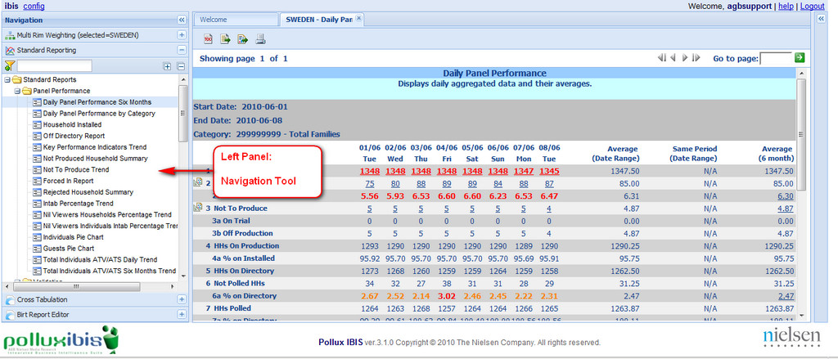

**Figure 1: Left Panel Navigation Tool**

**6.2 Windows Left Panel Rim Weighting**

For those operations that have more than one Pollux environment (such as tests environments, to validate on trial households, parallel productions or platforms), **IBIS** provides the capability to choose the environment to run the reports from.

A single environment has been selected as default, so every time users login into **IBIS** it goes straight to that reporting environment (main or QC environment). If the default environment is not the correct one and/or you wish to change it, please contact the Pollux Product Manager to adjust it.

The default environment name is always displayed at the “Multi Rim Weighting” item (at the top of the Navigation Menu or left pane). If users wish to select another environment, then open the menu to select among the available items (environments).

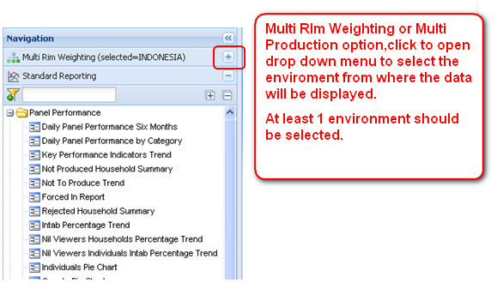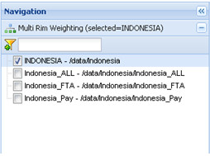

**Figure 1: Accessing Rim Weighting**

For those users that have access to the “**Configurator tool**”, it has been adapted to follow the “Multi Rim Weighting” concept as well, so when accessing the “**Category Group Tool**” (Family or Individuals), the users must select the environment where the groups will be configured for.

**6.3 Button Functions**

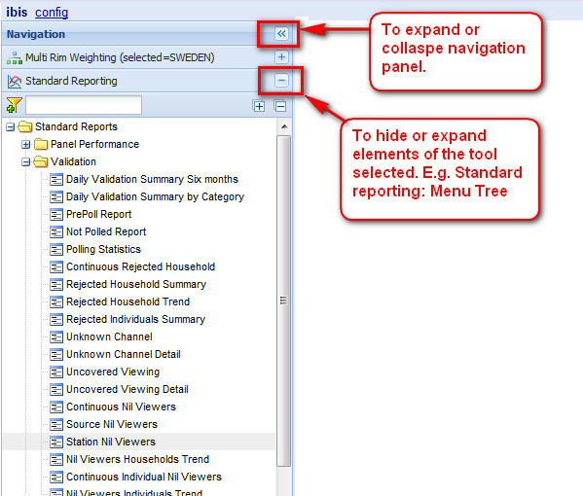

**Figure 1: Expand,Collaspe and Hide** **Buttons**

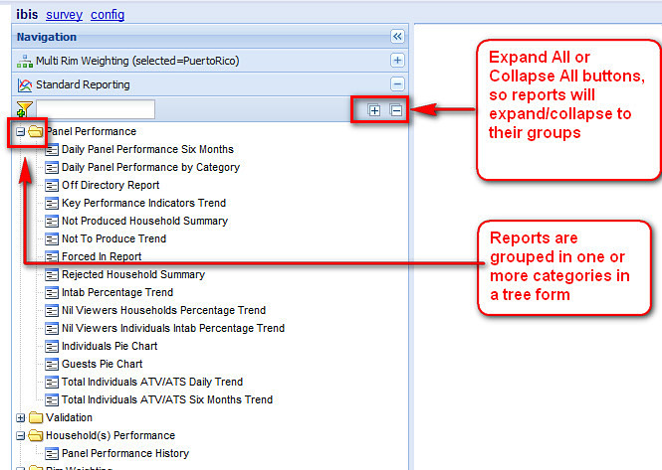

**Figure 2: Expand and Collaspe All buttons**

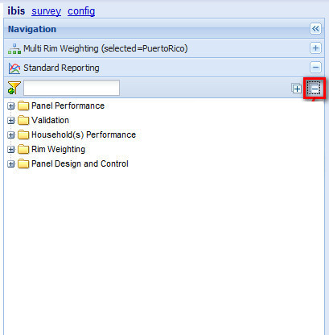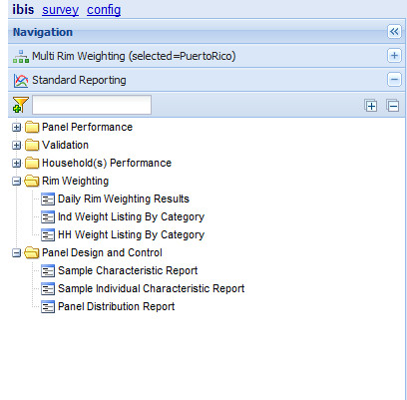

**Figure 3: Collaspe All**                                                                       

**Figure 4: Expand Selected Groups**

**6.4 Search Function**

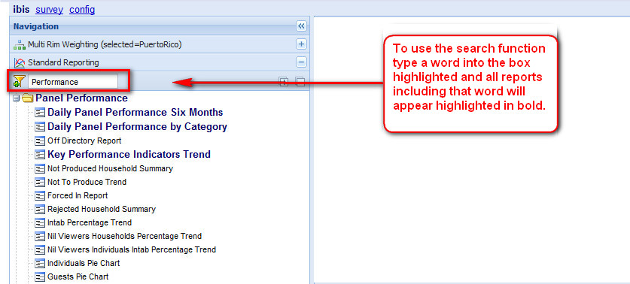

**Figure 1: Search Function**

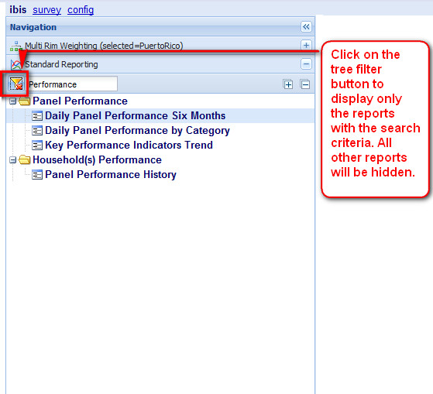

**Figure 2: Tree Filter**

**7. Windows Right Panel**

**7.1 Parameter Window**

The right panel is where the reports parameters are displayed and/or modified.

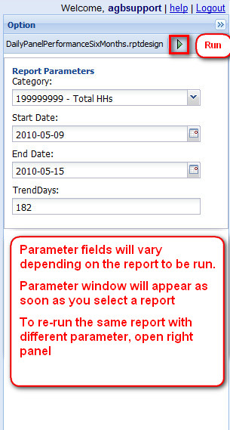

**Figure 1: Parameter Window**

Note:

**IBIS** reports are based on Family Categories as the main source for filtering information contained in each report.

Individual Categories cannot be used as filters due to the way the data is calculated and stored in the database, therefore Individual Categories are not displayed in the drop down menu.

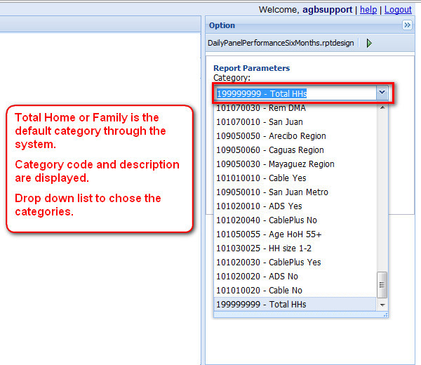

**Figure 2: Report Categories**

**7.2 Parameter Date**

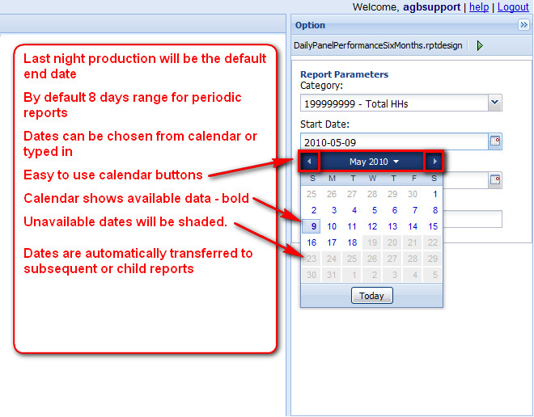

**Figure 1: Calendar in Parameter Window**

**7.3 Parameter Examples**

**IBIS** has an inbuilt help system that guides users on the content and format of the parameters to be inserted.

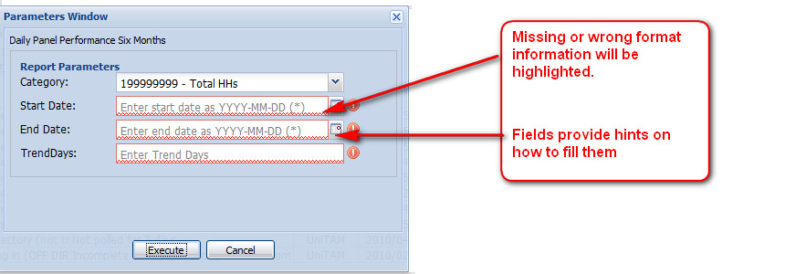

**Figure 1: In Built Help System**

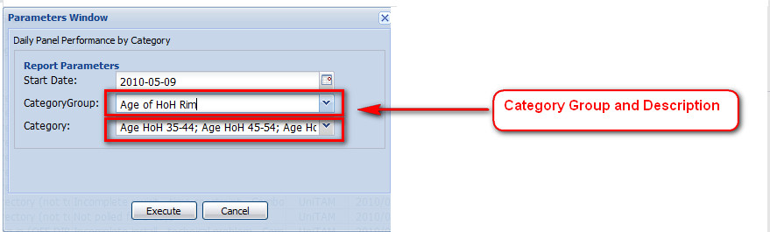

**Figure 2: Category Group and Description**

Reports have been configured following Nielsen’s best practices, recommended parameters are displayed by default, though if the “operation” (country) has reached a higher quality standard, please contact your Pollux Product Manager ([Fatima.Abreu@nielsen.com](mailto:Fatima.Abreu@nielsen.com)) to get guidance on how to customize the system to reflect the local parameters as default.

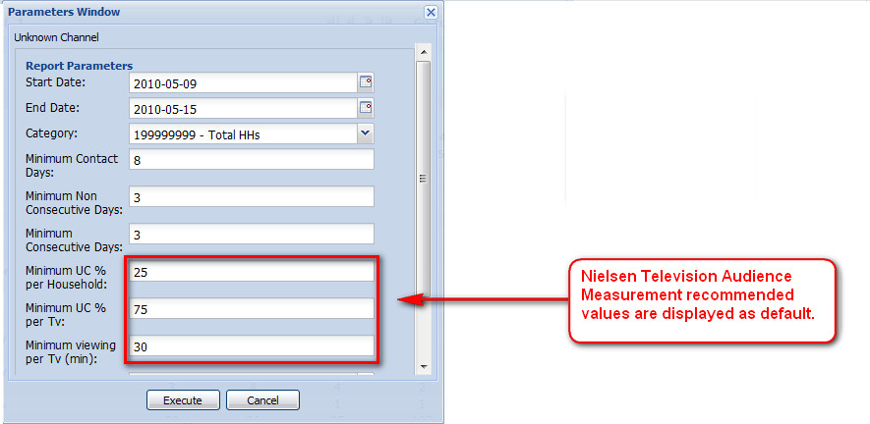

**Figure 3: Default Values**

**8. Central Panel**

**8.1 Content Area**

 The working area where the tools and reports will be displayed.

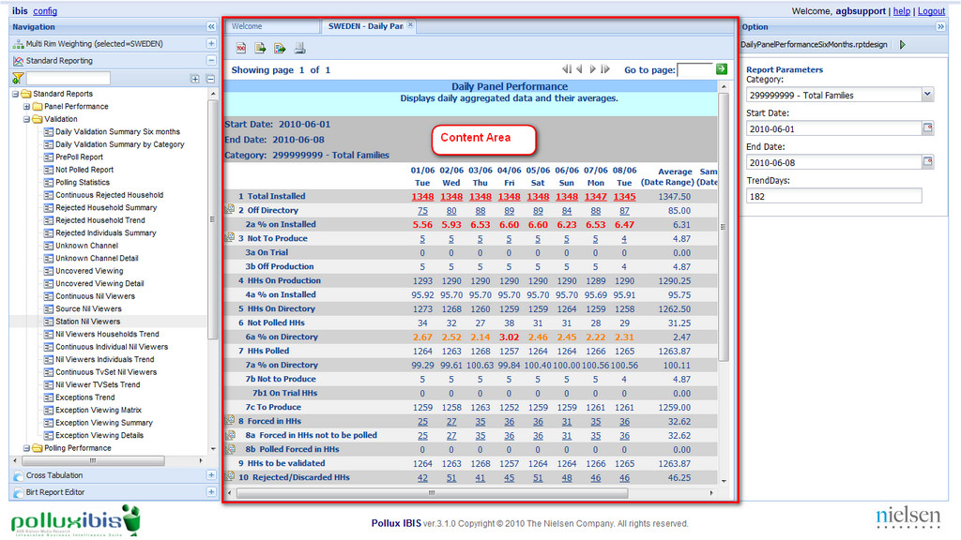

**Figure 1:Report Content Area**

**8.2 Content Area Main Page**

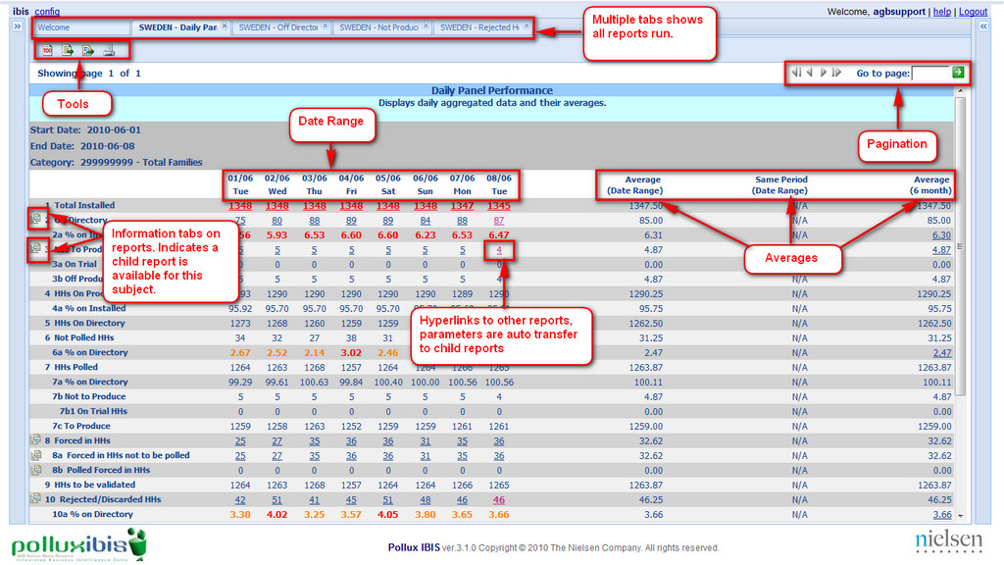

.

**Figure 1: Detailed Content Area**

  Macro - Micro perspective view of the data, at the same time. Main Reports contain:

•         Last night results are the default.

•         Last 8 days as standard range, provides one week + same day last week.

•         Average of the range.

•         Same period last year.

•         Average of the last 6 months (from end date backwards)

•         Average of the data available in DWH if it is less than 6 months.

•         N/A = Not available, if no data is available at the Data Warehouse.

  Hyper Links: Each underlined value links to another related report. It is possible to define a chain of linked reports and switch between them.

•         Hyper linked information and multi-tab feature permits easy navigation.

•         Underline blue number = Link to another report.

•         Bold Blue number =  Link just executed (last executed).

•         Purple number = link executed sometime during the session.

**8.3 Report tabs**

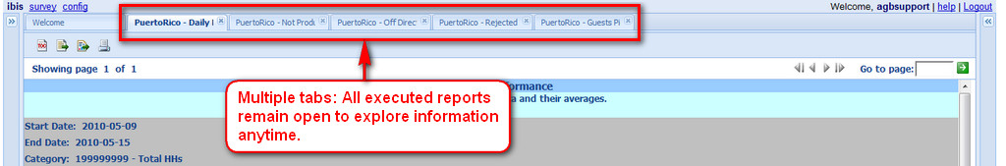

**Figure 1: Multiple Tabs**

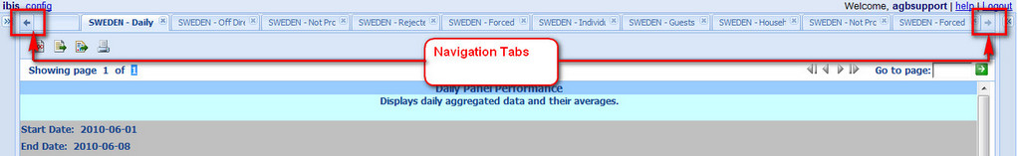

**Figure 2: Navigation Tabs**

Navigation button allows scrolling horizontally throughout the open tabs.Tabs can be closed any time.

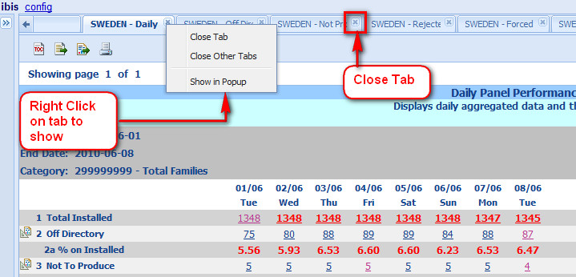

**Figure 3: Close Tabs**

Right Click on the Tab to:

* Close Tab
* Close Other Tabs: The current Tab will remain open
* Show the tab in a Popup (floating) window type.

For Floating Windows, users can:

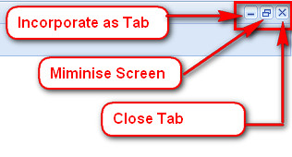

**Figure 4: Floating Windows**

**8.4 Tools**

**IBIS** is an interactive system that has been designed to work on screen. Printing documents or exporting to other software will eliminate the advances of “iteration” or data mining.

Print functionality has been incorporated to provide information (reports) to those who do not have access to our system, such as clients, JIC, auditors.

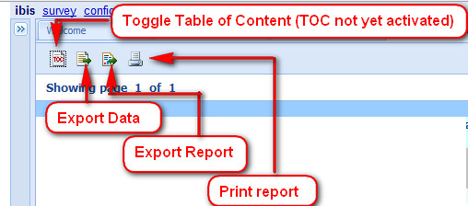

**Figure 1: Tools**

Export to - Excel, PostScript (old printers - backwards compatibility), PDF, Word, Power Point

Print:

* HTML(Hypertext Mark-up Language, the predominant [markup language](http://en.wikipedia.org/wiki/Markup_language) for [web pages](http://en.wikipedia.org/wiki/Web_page) .)
* PDF (Portable Document format)

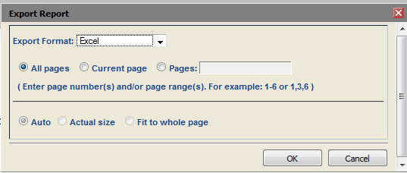

**Figure 2:  Export to File**

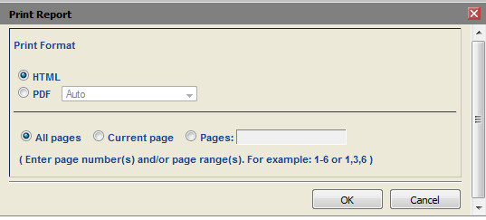

**Figure 3: Print Report**

Export/Print options:

* All Pages
* Current page
* Pages: to indicate a range of pages
* Auto: **IBIS** will fix the page numbers automatically. It is use as default option
* Actual size: to fit same quantity of pages as per screen (no adjustments)
* Fit to whole page: to fit the content to only one page.

**8.5 Pagination**

If a report contains more than one page, then it will show which page is open or currently displayed, and how many in total.

With the page navigator tool, the user can choose which page to jump too.

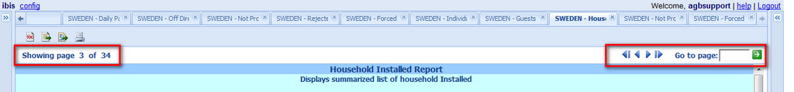

**Figure 1: Pagination**

**9. Additional Pollux Ibis Features**

**9.1 Click and Go**

The following features are available throughout the reports:

**Click and Go** :

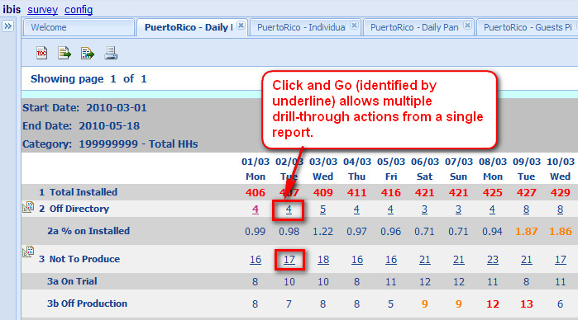

**Figure 1: Click and Go**

Active on right click of mouse.It is rendered using a multiple level context menu:

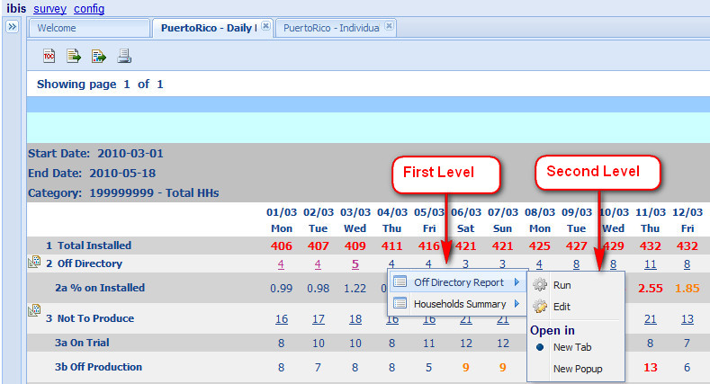

**Figure 2: Level Contect Menu**

  First level shows target reports defined for each parent report cell.

  Second level menu, provides the following operation:

Run: executes directly target report using parent generated parameters;

Edit: executes target report, with optional re-inserting of report parameters .

**9.2 Help Service**

Row help: Direct link in any single row. It displays the meaning of the information on display.



**Figure 1: Row Help**

Cell help: a simple tool tip or balloon appears while hovering over the report. It shows a short description or legend.



**Figure 2: Cell Help**

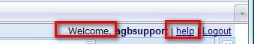

**Figure 3: Accessing Welcome and Help pages**

  Welcome page.

 Standard help file.

**9.3 Sort and Order**

An arrow within the column indicates the sorting direction (ascending or descending) Click on arrow to change direction.

In some of the reports sort by choosing one column at a time.

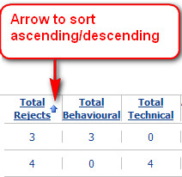

**Figure 1: Sort and Order**

**10. Configuration Tool**

**10.1 Introduction to Configuration Tool**

It is a tool to easily configure some **IBIS** features and functionalities.

It’s access should be limited to high level users, such as production director/ manager or system administrators,as the settings will affect all users at the same time and should be kept under control.

At the moment, it is possible to:

**Category** **Tool:** Allow the association of categories into groups (to create group of categories) within the Family and Individual category.

**Data Integrity Tool:** To establish thresholds for conditional formatting. E.g To highlight the Intab levels when below  90%.

**Scheduling configuration:** Tool to configure the “scheduling and delivering” of standard reports via email. This tool substitutes the “daily Book” functionality of Pollux.

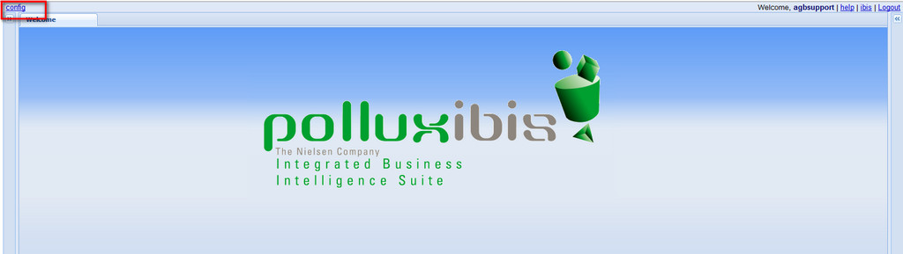

**Figure 1: Accessing Configuration Tool.**

**10.2 Accessing Configuration tools**

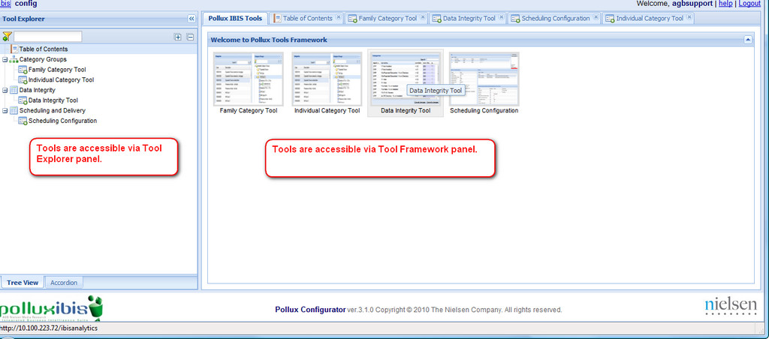

**Figure 1: Accessing Tools**

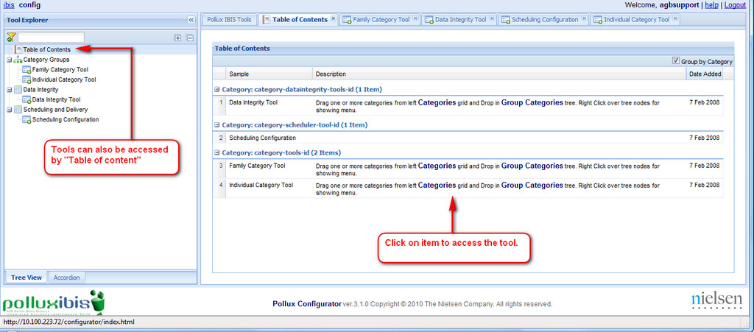

**Figure 2: Additional Ways to Access Tools**

**10.3 Main page**

Like the**IBIS** Report, the “Configurator Tool” also has a dashboard.

* Left Panel: Is the “navigation” to access the tools available within the “Configurator”
* Central Panel: Is the working area where the tools will be displayed.

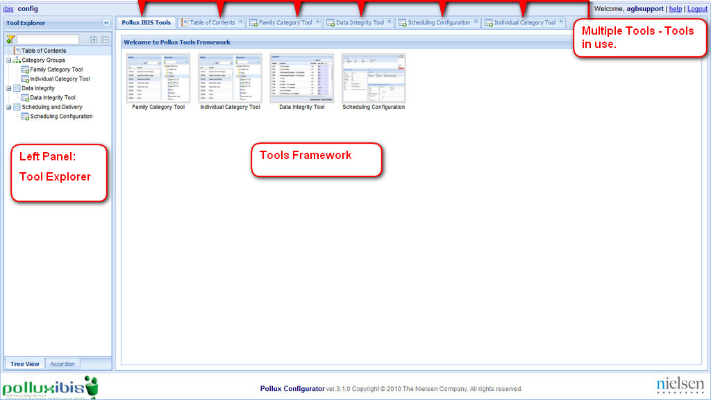

**Figure 1: Configuration Tool Main page.**

**10.4 Left Panel Configuration**

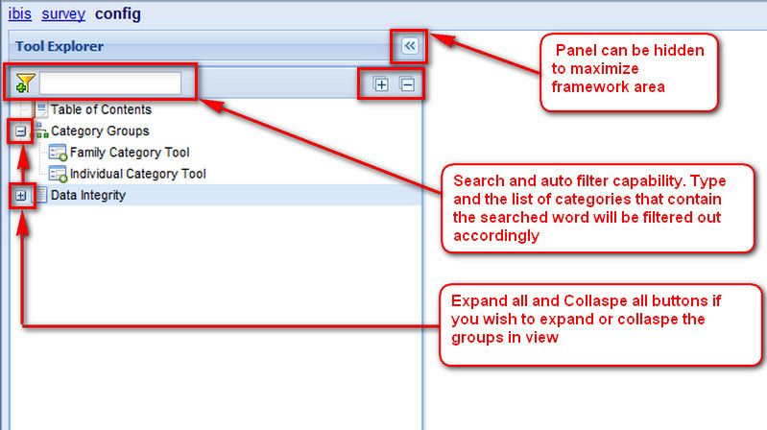

**Figure 1: Left Panel of Configuration Tool**

**10.5 Family and Individual Category tool**

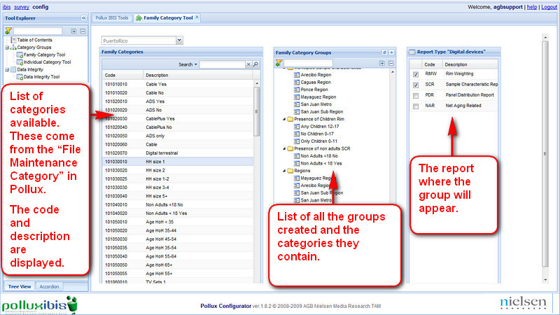

**Figure 1: Family Category Tool**

**10.5.1 Family Category tool Main Page**

All functions available in the Family Category tool are also available for the Individual Category tool, in this chapter we use the family category tool to demonstrate how to use these.



**Figure 1: Family Category Tool**

**10.5.2 Configuration Search**

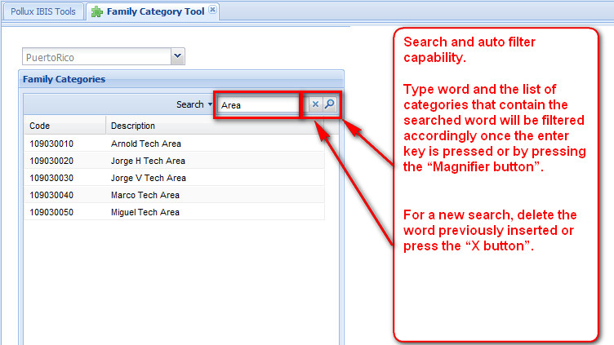

**Figure 1: Search and Auto Filter Tool**

**10.5.3 Functions**

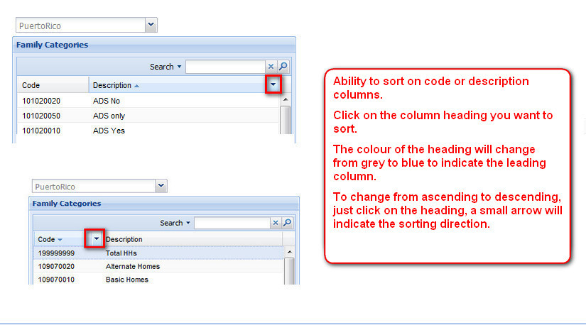

**Figure 1: Sorting Columns**

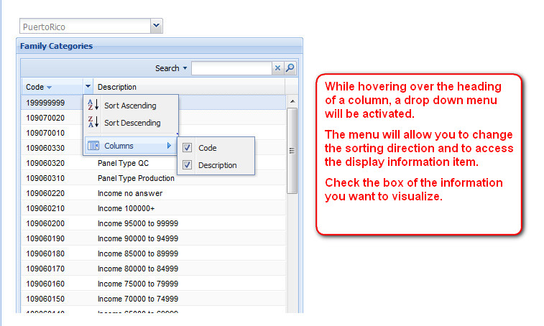

**Figure 2: Sorting Options**

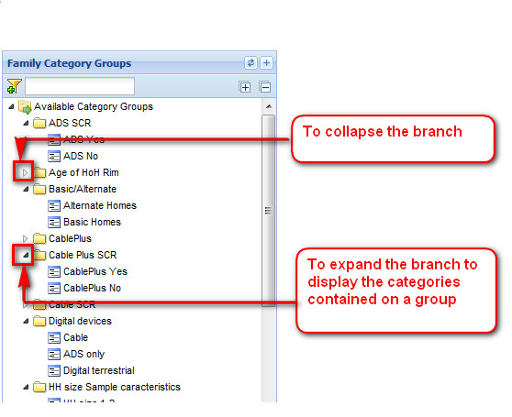

**Figure 3: Collaspe and Expand**

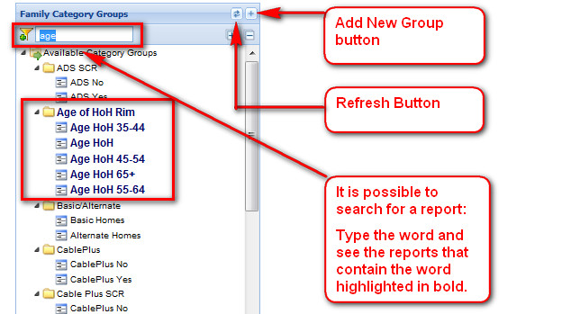

**Figure 4: Add,Search and Refresh**

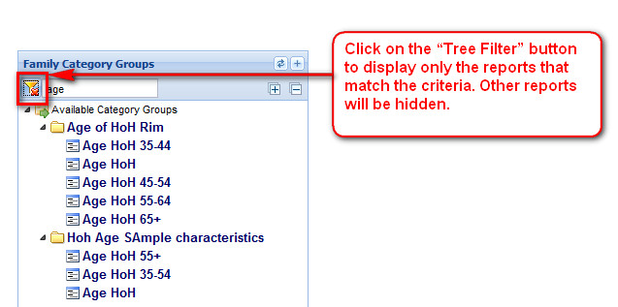

**Figure 5: Tree Filter**

**10.5.4 Creating groups**

      How to create new category groups:

  1- Create the Category Group folder.

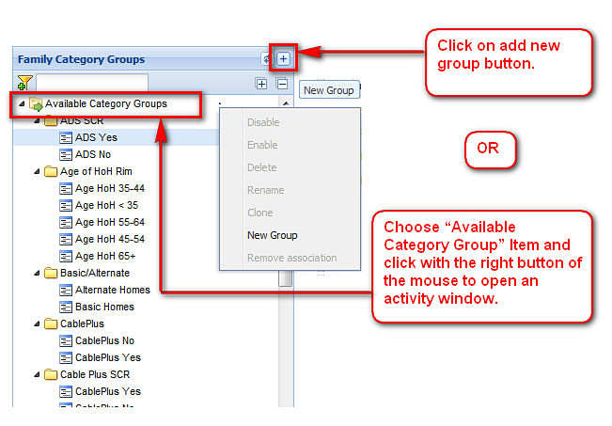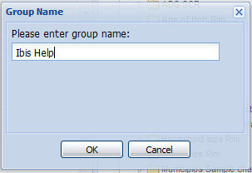

Pop up box appears, enter group name and press OK

**Figure 1: Creating New Category** **Group.**

Once created a new folder will appear in the menu tree.

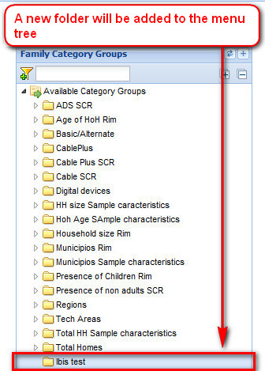

**Figure 2:  New Folder Created**

2.       Select categories from “Family Categories” windows and using the Drag & drop functionality drop them over the newly created group. The “control key” can be used to select non consecutive categories from the “Family Categories” window.

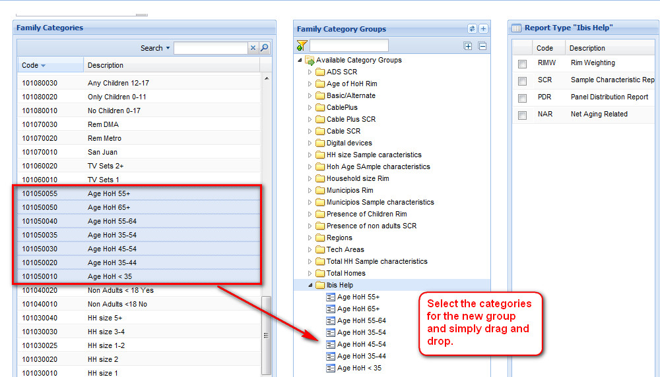

**Figure 3: Adding Categories to Groups.**

3.       Select from “Report Type” the report in which the new category group will be displayed.

* RIMW  = Rim Weighting
* SCR = Sample Characteristic Report
* Panel Distribution Report
* Net Aging Related

**Multiple selections are allowed** (meaning that the same group could be available for RMW,SCR etc.)

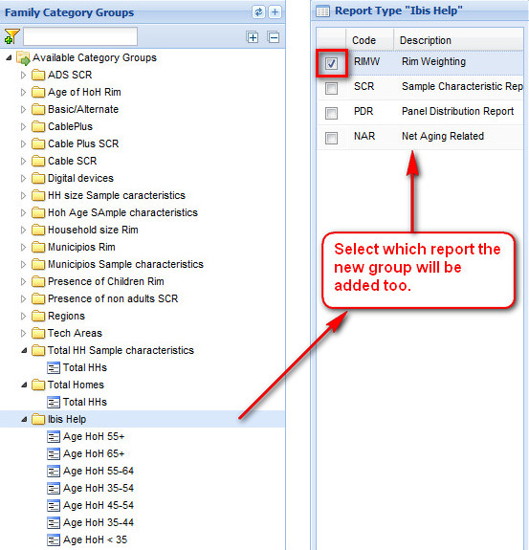

**Figure 4: Choosing Report for New Category Groups.**

**10.5.5 Activity window**

Other Function tasks available are:

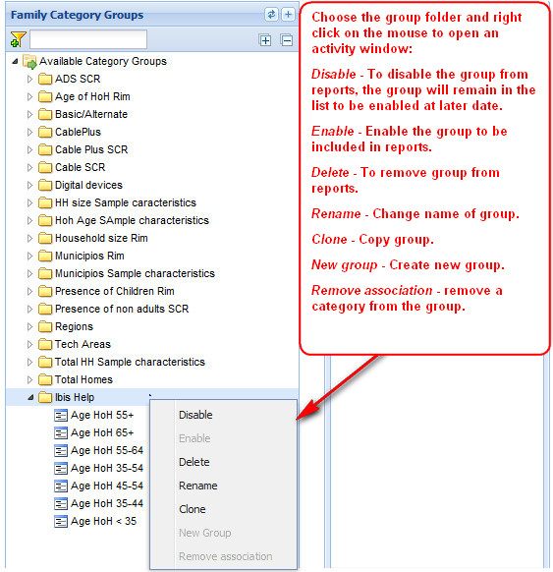

**Figure 1: Activity Window**

**10.6 Data Integrity Tool**

**10.6.1 Data Integrity**

**Data Integrity Tool:** To establish thresholds for conditional formatting E.g To highlight the Intab levels when below  90%.

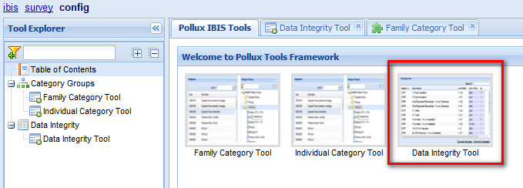

**Figure 1: Accessing Data Integrity Tool**

Click on the Data Integrity Tool to open it:

**10.6.2 Data Integrity Main Page**

The Data Integrity tool has the ability to choose which category the conditional formatting will be applied, therefore more than one set of conditional formatting can co-exist (before only one set of rules could be configured). This feature complements the “Multi Rim Weighting” (environment selection) already explained in previous pages.

This is especially important when using the reports Daily Panel Performance by Category and Daily Validation summary by Category, but not limited to them, as any other category could be configured (areas, meter type based, etc).

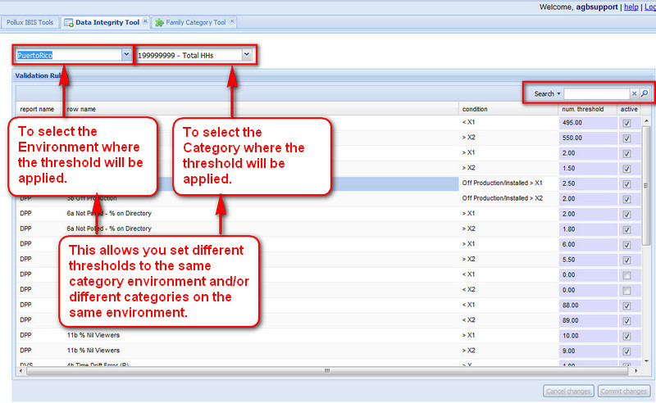

**Figure 1: Data Integrity Main Page**

**10.6.3 Search and Main Menu**

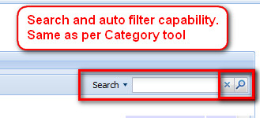

**Figure 1: Search Tool**

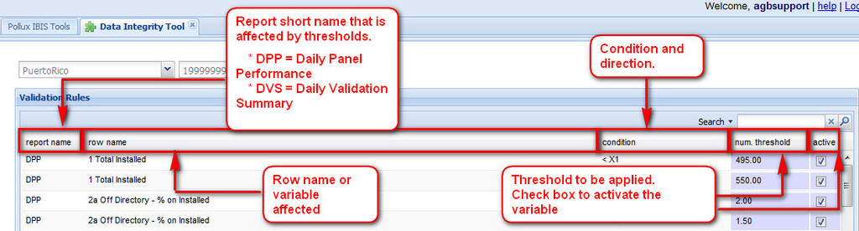

**Figure 2:Detailed Data Integrity**

**10.6.4 How to set thresholds**

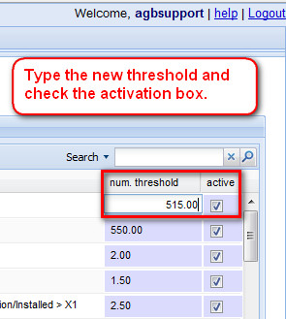

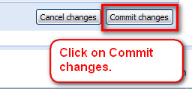

**Figure 1: New Threshold**

Once you have clicked on Commit changes, go back and re-run to see the conditional formatting being applied (if condition meets threshold).

To modify a threshold double click on the figure and re-write.

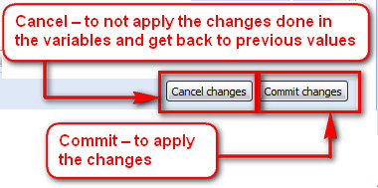

**Figure 2: Cancel or Commit**

You must click on Commit changes so the threshold is transferred from the interface to the database.

**10.6.5 Rules and thresholds DPP**

Below is a list of threshold examples for the Daily panel performance, these are dependent by country and panel size.

|  |  |  |  |  |
| --- | --- | --- | --- | --- |
| Report | Field Name | Measure | Condition | Color |
| DPP | **1  Total Installed** | Absolute | < X1 | Red |
| To check low levels of installed HHs (less than) |
| DPP | **1  Total Installed** | Absolute | > X2 | Red |
| To check high levels of installed HHs (more than) |
| DPP | **2a Off Directory - % on Installed** | % | > X1 | Red |
| Levels are too high. Out of range, actions must be taken |
| DPP | **2a Off Directory - % on Installed** | % | > X2 | Orange |
| Warning level. Levels are getting higher, actions should be taken |
| DPP | **3b Off Production** | % | Off Production/Installed>X1 | Red |
| Levels are too high. Out of range, actions must be taken |
| DPP | **3b Off Production** | % | Off Production/Installed>X2 | Orange |
| Warning level. Levels are getting higher, actions should be taken |
| DPP | **6a Not Polled - % on Directory** | % | >X1 | Red |
| Levels are too high. Out of range, actions must be taken |
| DPP | **6a Not Polled - % on Directory** | % | >X2 | Orange |
| Warning level. Levels are getting higher, actions should be taken |
| DPP | **10a Rejected/Discarded - % on Directory** | % | >X1 | Red |
| Levels are too high. Out of control, actions must be taken! |
| DPP | **10a Rejected/Discarded - % on Directory** | % | >X2 | Orange |
| Warning level. Levels are getting higher, actions should be taken |
| DPP | **11  Intab** | Absolute | <X1 | Red |
| Levels are low. Out of control, actions must be taken! |
| DPP | **11  Intab** | Absolute | <X2 | Orange |
| Warning level. Levels are getting lower, actions should be taken |
| DPP | **11a Intab - % on Installed** | % | <X1 | Red |
| Levels are low. Out of control, actions must be taken! |
| DPP | **11a Intab - % on Installed** | % | <X2 | Orange |
| Warning level. Levels are getting lower, actions should be taken |
| DPP | **11b % Nil Viewers** | % | >X | Red |
| Levels are too high. Out of control, actions must be taken! |

**Table 1: Rules and Thresholds Daily Panel Performance**

**Red**= Indicates a variable that is "out of range" either too high/low (dependent on the meaning of the variable) and requires urgent action to be taken in order to correct the trend.

**Orange** = Indicates a "Warning" Level, actions should be taken before the situation turns into "out of range".

**10.6.6 Rules and thresholds DVS**

Below is a list of threshold examples for the Daily Validation Summary, these are dependent by country and panel size.

|  |  |  |  |  |
| --- | --- | --- | --- | --- |
| Report | Field Name | Measure | Condition | Color |
| DVS | **4b Time Drift Error** | Absolute | >X | Red |
| Levels are too high. Out of control, actions must be taken! |
| DVS | **4i Percenatge UV** | % | Percentage UV/Rejected >X1 | Red |
| Levels are too high. Out of control, actions must be taken! |
| DVS | **4i Percenatge UV** | % | Percentage UV/Rejected >X2 | Orange |
| Warning level. Levels are getting higher, actions should be taken to correct the situation |
| DVS | **4k Unknown Channel** | % | Unknown Channel/Rejected>X1 | Red |
| Levels are too high. Out of control, actions must be taken! |
| DVS | **4k Unknown Channel** | % | Unknown Channel/Rejected>X2 | Orange |
| Warning level. Levels are getting higher, actions should be taken to correct the situation |
| DVS | **7b % Uncovered Viewing from validated viewing** | % | >X1 | Red |
| Levels are too high. Out of control, actions must be taken! |
| DVS | **7b % Uncovered Viewing from validated viewing** | % | >X2 | Orange |
| Warning level. Levels are getting higher, actions should be taken to correct the situation |
| DVS | **7c % Unknown Channel(s) from validated viewing** | % | >X1 | Red |
| Levels are too high. Out of control, actions must be taken! |
| DVS | **7c % Unknown Channel(s) from validated viewing** | % | >X2 | Orange |
| Warning level. Levels are getting higher, actions should be taken to correct the situation |

**Table 1: Rules and thresholds Daily Validation Summary**

**Red**= Indicates a variable that is "out of range" either too high/low (dependent on the meaning of the variable) and requires urgent action to be taken in order to correct the trend.

**Orange** = Indicates a "Warning" Level, actions should be taken before the situation turns into "out of range".

**10.6.7 Rules and thresholds PPH**

Below is a list of threshold examples for the Panel Performance History, these are dependent by country and panel size.

|  |  |  |  |  |
| --- | --- | --- | --- | --- |
| Report | Field Name | Measure | Condition | Color |
| PPH | **Forced turnover > n months** | Absolute | >X | Red |
| Household has reached the maximun time in panel. It should be subtituted. |
| PPH | **% Days Intab n (error)** | % | <X1 | Red |
| Household is not performing well. Percentage of Intab days is low. A subtitution should be considered if trend can't be changed shortly. |
| PPH | **% Days Intab n (warning)** | % | <X2 | Orange |
| Household is a low performer. Look for a subtitution. |

**Table1: Rules and thresholds Panel Performance History**

**Red** = Indicates a variable that is "out of range" either too high/low (dependent on the meaning of the variable) and requires urgent action to be taken in order to correct the trend.

**Orange** = Indicates a "Warning" Level, actions should be taken before the situation turns into "out of range".

**10.6.8 Rules and thresholds PD**

Below is a list of threshold examples for the Panel Distribution, these are dependent by country and panel size.

|  |  |  |  |  |
| --- | --- | --- | --- | --- |
| Report | Field Name | Measure | Condition | Color |
| PD | **% Households Installed over ideal (highest threshold)** | % | > X1 | Orange |
|  | The quantity of Households is higher than neeeded. Default value should be 100% |
| PD | **% Households Installed over ideal (lowest threshold)** | % | < X2 | Red |
|  | The quantity of Households is lower than neeeded. Default value should not be less than 80% |
| PD | **Minimum Net Aging changes** | None | Just Active or not. Default is Active | Red |
|  | Categories which will have a negative "Net Aging" should be highlighted in red. In this category will be necessary to install additional household to compensate the lost of Households (Count of HHs that will change from one category to other as consequence of demos update related to age) |
| PD | **Consecutive weeks out of ideal (warning)** | % | >X1 | Orange |
|  | The number of consecutive weeks since the category has not reached the "Panel Ideal". Default value should be 8 weeks.Warning level. Levels are getting higher, actions should be taken to correct the situation. |
| PD | **Consecutive weeks out of ideal (error)** | % | >X2 | Red |
|  | The number of consecutive weeks since the category has not reached the "Panel Ideal". Default value should be 12 weeks. Levels are too high. Out of control, actions must be taken! |
| PD | **Highest Actual/Ideal rank** | None | Just Active or not. Default is Active | Green |
|  | To highlight catgeories which "Prioritization Rank" has been classified from 1 to 3 |

**Table 1: Rules and Thresholds Panel Distribution**

**Red** = Indicates a variable that is "out of range" either too high/low (dependent on the meaning of the variable) and requires urgent action to be taken in order to correct the trend.

**Orange** = Indicates a "Warning" Level, actions should be taken before the situation turns into "out of range".

**10.6.9 Rules and thresholds MCOM.PSOS and PPL**

Below is a list of threshold examples for the Meter Communication Report(old meter technology MCOM) the Polling Statistics on Sample Report(PSOS) and Prepoll Report (PPL), these are dependent by country and panel size.

|  |  |  |  |  |
| --- | --- | --- | --- | --- |
| Report | Field Name | Measure | Condition | Color |
| MCOM | **Excessive Statements Days Downloaded (warning)** | Absolute | >= X1 | Orange |
|  | Consecutive number of days downloaded in a single polling process.  Warning if between 3 to 5 days. |
| MCOM | **Excessive Statements Days Downloaded (error)** | Absolute | >= X2 | Red |
|  | Consecutive number of days downloaded in a single polling process.  Action required if higher than 6 days. |
| MCOM | **Power Off Warning** | None | Just Active or not. Default is Active | Orange |
|  | To highlight Meters that have "Power Off" during polling time. If "Power Off" and "Low Battery" are concurrently, the highlight will red. |
| MCOM | **Low Battery Level Warning** | None | Just Active or not. Default is Active | Orange |
|  | To highlight Meters that have "Low Battery Level"  If "Power Off" and "Low Battery" are concurrently, the highlight will red. |
| MCOM | **Main TV Set Meter Power Off Warning** | None | Just Active or not. Default is Active | Green |
|  | To indicate "Main TV Set" of the Household. It is set from "Unit Page" HHMaster - field "Main TV" (Yes/No). If field is empty or null, set Unit 1 as "Main TV" |
| PPL | **Highlight problems** | None | Just Active or not. Default is Active | Orange |
|  | To highlight any cell that show a "Yes" to easily spot the problem or missing information. |
| PSOS | **% Unsuccessful calls (meter not reached) over successful** | % | >X | Red |
|  | Number of unsuccessful attempts greater than X% over successful calls performed on a given line. Default 30% |
| PSOS | **% Unsuccessful calls (meter reached) over successful** | % | >X | Red |
|  | Number of unsuccessful attempts greater than X% over successful calls performed on a given line. Default 30% |

**Table 1: Rules and Thresholds for Meter Communication Report, Polling Statistics on Sample Report and the PrePoll Report.**

**Red** = Indicates a variable that is "out of range" either too high/low (dependent on the meaning of the variable) and requires urgent action to be taken in order to correct the trend.

**Orange** = Indicates a "Warning" Level, actions should be taken before the situation turns into "out of range".

**10.7 Scheduling Configuration**

**10.7.1 Scheduler Editor**

Scheduler Editor is a module of the Pollux Configurator application. To open the editor, access the Configurator and click on Scheduling Configuration module, either in the modules tree or in the dashboard.

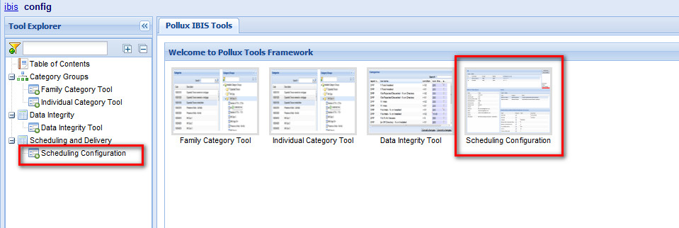

**Figure 1: Accessing Scheduling Configuration**

**10.7.2 Editor Layout**

Scheduler Editor is divided into four main areas:

* **Jobs**: Details of all the jobs the Scheduler has to manage. A job is a set of Actions (e.g. run a report) to execute all together at a specific time.
* **Delivery Method Options**: Each Job can specify a different method to report the results of its Actions. At the moment only SMTP method is implemented.

           Delivery Method Options area allows you to configure all the parameters specific for the chosen method.

* **Actions**: This area lists all the Actions the selected Job has to execute when it runs.
* **Parameters**: In case the Action is run a report, the report requires that it's parameters have to be set. This area allows you to specify how to set these parameters.

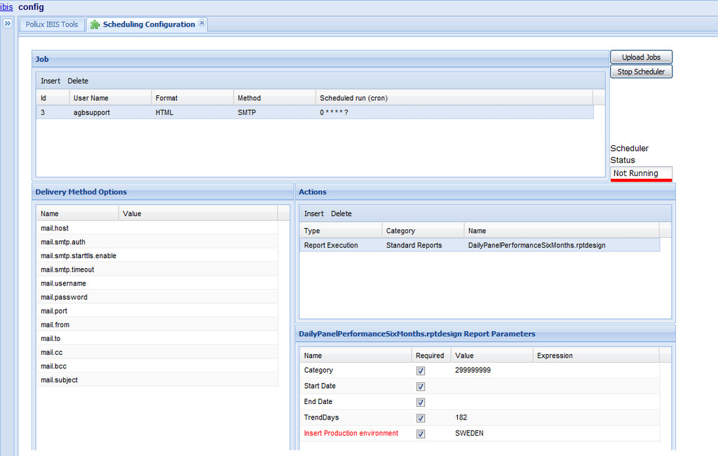

**Figure 1: Scheduling Configuration Main Page**

**10.7.3 Dependencies**

Different areas in the Editor are linked in two master details relations.

A Job is linked to Actions and Options. If you select another Job, Options and Actions list will change accordingly.

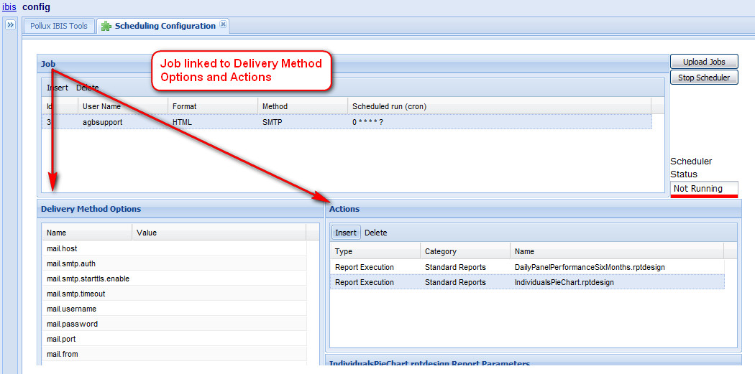

**Figure 1: Job linked to Delivery Method Options and Actions**

Each Action is linked to its set of Parameters. Selecting another Action, the set of Parameters will change accordingly.

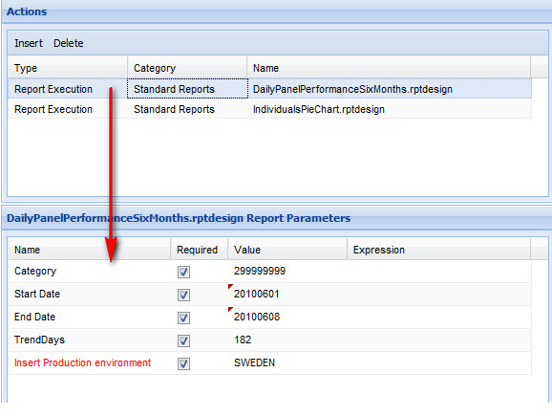

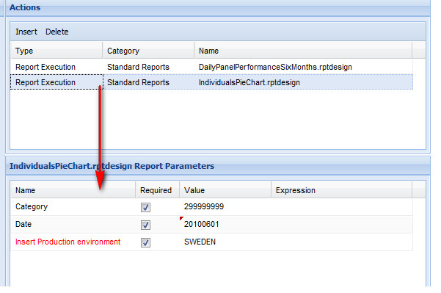

**Figure 2: Example of Diffferent reports changing parameters**

**10.7.4 Add a New Job**

To add a new Job, click on ‘Insert’ button in the Jobs grid toolbar.

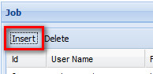

**Figure 1: Add new job**

A new Job will be inserted in the Jobs grid and automatically selected. Options, Actions and Parameters grid will be cleared, waiting for your settings.

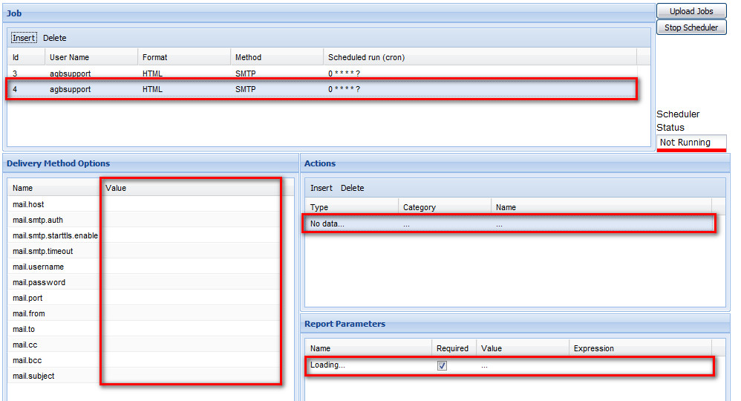

**Figure 2: Delivery options, Actions and Report parameter grid**

**10.7.5 Delivery Format Setting**

To choose the format to use when export the reports, click on ‘Format’ cell and select what you want in the combo box.

Allowed formats are: HTML, PDF, DOC (Microsoft Word), XLS (Microsoft Excel), PPT (Microsoft PowerPoint)

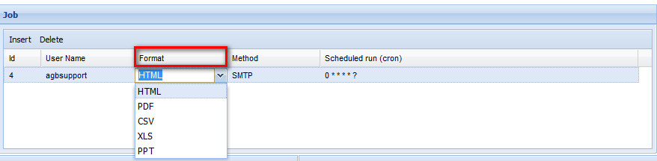

**Figure 1: Choosing Format**

**10.7.6 Cron Expression**

Each Job can be scheduled for different times. When you create a new Job, it is automatically scheduled to start at the beginnig of each minute (don’t worry, the Job is not active yet). To set/modify the cron expression, click on ‘Scheduled run (cron)’ cell.

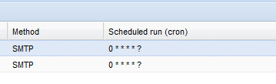

**Figure 1 Cron cell**

Cron Expression dialog will be opened.

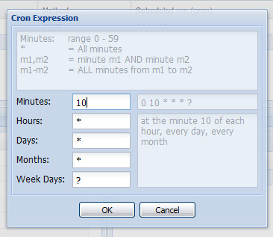

**Figure 2: Cron Expression Dialog box**

In this dialog you can set minutes, hours, months, day of month and/or day of the week when you want to automatically run your Job.

A legend for all allowed settings for each part of the expression is displayed in the upper info area.

Composed cron expression is written in the upper box, whereas a more readable explanation is reported in the box below.

Try to change the value in one of the text fields to see how the information changes.

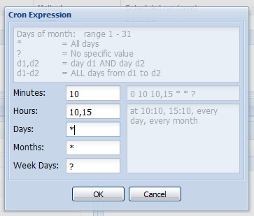

**Figure 3: Changing Values**

At the end, click ‘OK’ button to confirm your choice. New cron expression will be written in the relevant cell of Jobs grid.

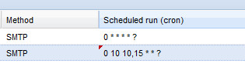

**Figure 4: Cron expression added to Job grid**

**10.7.7 Remove a Job**

To remove a Job, select it in the Jobs grid and click ‘Delete’ button in the grid toolbar.

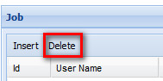

**Figure 1:Remove a Job**

Before removing the Job, the Editor will ask you to confirm your choice.

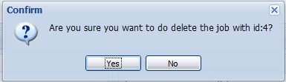

**Figure 2**: **Confirmation notice**

Job will be removed from Jobs grid and its dependencies from other grids.

**10.7.8 Add a New Action**

To add a new Action, click on ‘Insert’ button in the Actions grid toolbar.

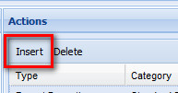

**Figure 1: Insert Button**

A popup window will allow you to choose the required action type (for the time being, only Report Execution) and required report amongst all the existing ones.

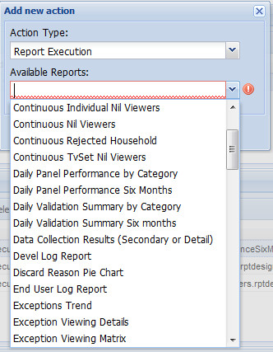

**Figure 2: Action Types and Report**

Clicking on ‘OK’ button, the new Action will be added to Action grid and the set of parameters for the Action will show in the Parameters grid.

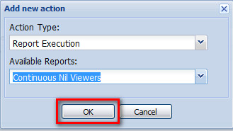

**Figure 3: Selecting report**

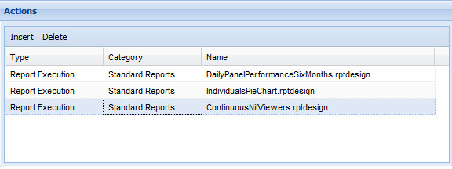

**Figure 4: Added report to actions**

**NOTE: If you don’t properly set all the parameter values, you are not allowed to select another Action or to add a new one. At the same time you are not allowed to select or add another Job.**

**10.7.9 Remove an Action**

To remove an Action, select it in the Actions grid and click ‘Delete’ button in the grid toolbar.

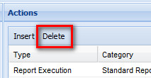

**Figure 1: Remove an Action**

Before removing the Action, the Editor will ask you to confirm your choice.

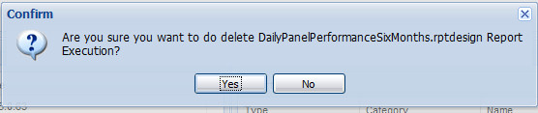

**Figure 2: Confirmation notice**

Action will be removed from the Actions grid with it's relevant parameters from the Parameters grid.

**10.7.10 Parameters Setting**

Each parameter can be set independently editing the relevant Value cell. Parameters highlighted in red are defined as ‘hidden’ in the report and their values can’t be modified.

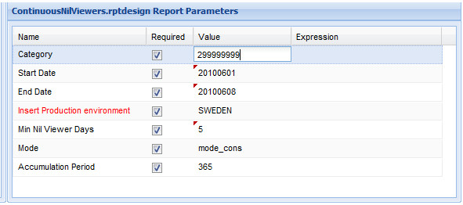

Date parameters in addition allow you to insert, instead of a fixed value, an expression to indicate today, yesterday, one week ago.

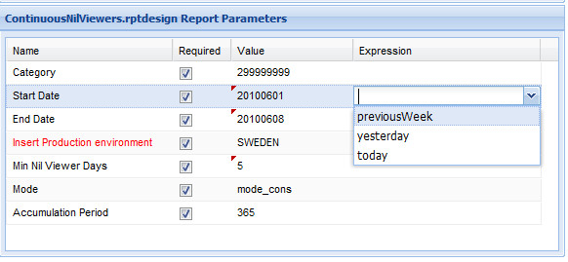

Delivered program will automatically substitute the expression with a proper value according to the time when it runs.

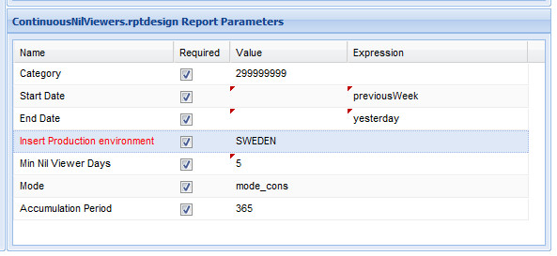

You cannot set a value and an expression together.

**10.7.11 Delivery Method Options**

Delivery Method Options can be set simply by editing the relevant Value cell. The list of options is predefined and can not be modified.

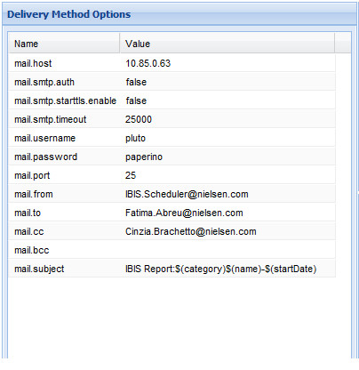

**Figure 1: Delivery Method Options table**

To set more than one mail address, separate them with a semicomma (e.g.*[fatima.abreu@nielsen.com;cinzia.brachetto@nielsen.com](mailto:e.g.fatima.abreu@nielsen.com;cinzia.brachetto@nielsen.com)*).

Some keywords can be specified in the mail.subject text. These keywords will be substituted with the proper values by the Deliver program. Available keywords are:

**name** the name of the report executed.

**category** category chosen as parameter if any.

**startDate** start date chosen as parameter if any.

**endDate** end date chosen as parameter if any.

**date** single date chosen as parameter if any.

**envProd** production environment parameter value.

Keywords must be specified using the syntax ***${keyword name}***

**mail.attach.isBooklet property*,*** if set to true and if job format is XLS (Excel), allows to compact all reports results in a single file having different worksheets.

**10.7.12 Status,Upload Jobs and Stop**

The status of the Scheduler/Deliver is displayed in the relevant box at the right side of the Editor page.

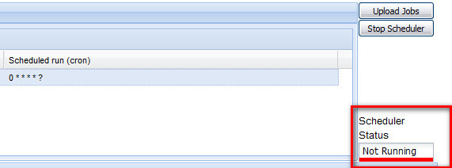

**Figure 1:Status of the Scheduler/Deliver**

**Jobs upload**

To upload jobs you created or modified, click on 'Upload Jobs' button.



**Figure 2: Upload Jobs**

This will automatically start the Scheduler in case it is in 'Not Running'or 'StandBy' status.

A message will inform you when the Scheduler has been uploaded and started (or will signal an error, in case).

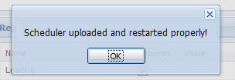

**Figure 3: Pop - Up Message**

The status of the Scheduler/Deliver is displayed in the relevant box at the right side of the Editor page.

Once job has been uploaded the Scheduler Status is refreshed accordingly.

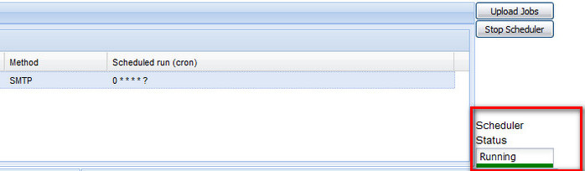

**Figure 4: Scheduler Status**

To stop the Scheduler/Deliver program, click on 'Stop Scheduler' button.

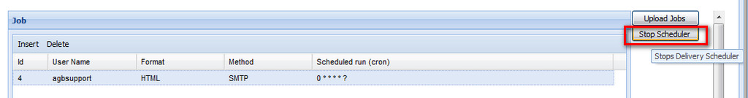

**Figure 5: Stopping Scheduler**

Message will appear to inform you that the action has been executed properly.

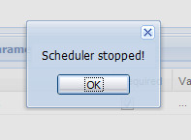

**Figure 6: Pop-up Message**

and status will change to 'StandBy'

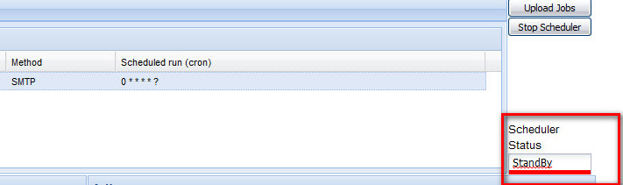

**Figure 7: StandBy status**

**11. Working with Ibis**

**11.1 Work Flow**

**IBIS** workflow starts from the panel design and controls. This area is composed by reports to understand and to control the panel distribution. Weekly checks are recommended when panel is well balanced or more often otherwise.

Panel performance is where daily checks begin. It reflects the daily production results from the quantity of households installed, on directory, in production, polled,rejected, and finally in tab levels (households produced and released to the market in the output file.) Daily Panel Performance includes all the Key Performance Indicators (KPI).

Also at the panel performance level there are the Rim Weighting reports, which will indicate the results of the weighting process. Though the process will correct any unbalance in the sample, it will also introduce some distortions (statistical errors) which need to be looked at.

Quality Control is the heart of **IBIS** . There are numerous reports that cover in detail all known exceptions from not polled, rejected, nil viewers, validation issues, etc. The highlight point is, reports are automatically sorted to display the worst offenders (most consecutive days accumulated at the given exception) at the top of the list, beside the conditional formatting that help users.  The interactivity feature or drill down capabilities enable users an easy access to deep levels of information to better understand the details on each report and plan for appropriated actions.

To close, the full concept of **IBIS** is that it is a multi-environment tool. Analysis can be done on specific environments as well as on selected categories.

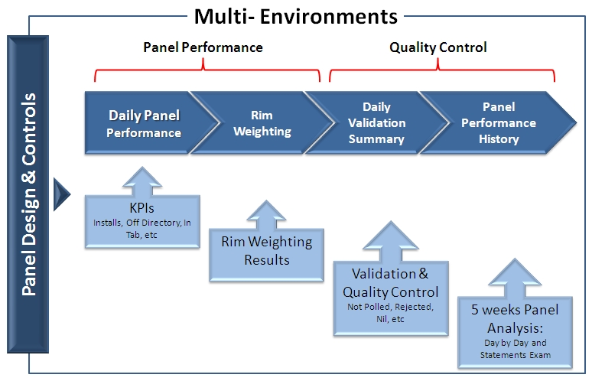

**Figure 1: Panel Design and Controls Work Flow.**

**11.2 Daily Panel Performance**

* Goal: Understanding Key Performance Indicators (KPI) of the panel

Frequency: Every Day! – It is the starting Point!

  It should be read from top to bottom and from left to the right!

                   both directions at the same time

                                    from the macro to micro view.

* + Total families
  + By sample, if applied.

8 days is the recommend date range.

* + Last night production results
  + 1 week worth of data for short term trend
  + Same day last week

Use Daily Panel Performance by Category to examine last night results split by category (e.g. area, meter type, SEC, etc).

**11.3 Daily Validation Summary**

* Goal = To understand the results of the validation process – Quality of the data.
* Frequency = Every Day – Essential to perform the quality control activities.
* It should be read from top to bottom and from left to right.

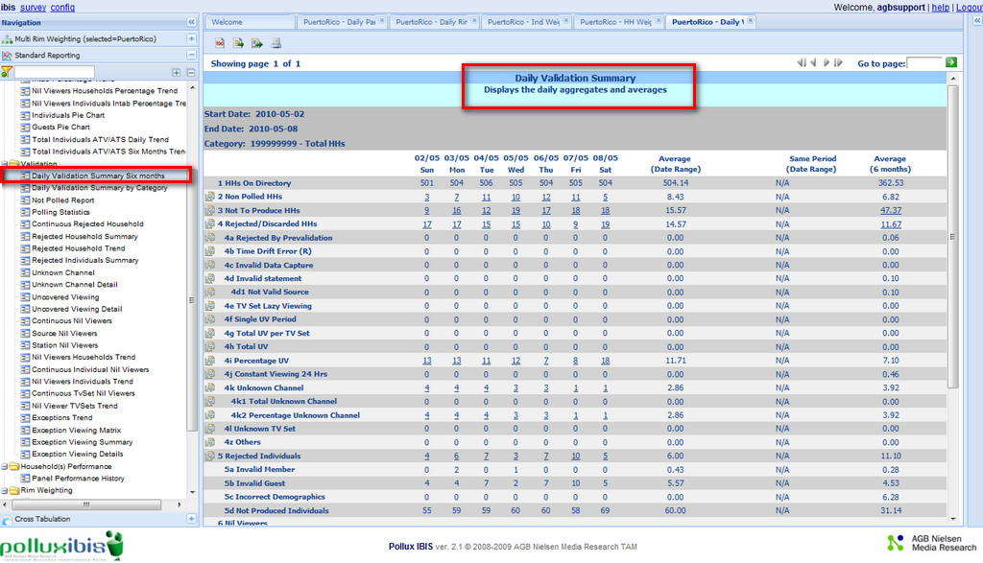

**Figure 1: Daily Validation Summary Main Page**

**11.4 Panel Performance History**

**Panel Performance History**

Goal: To understand the performance of each household over a period of 5 weeks.

* Frequency: Any time needed.

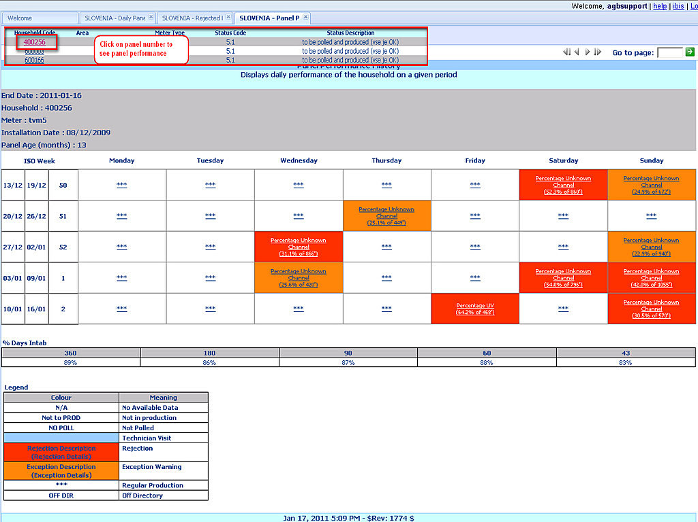

**Figure 1: Panel Performance History -  5 week View.**

**11.4.1 Statements**

MPI - Meter to Pollux interface - Raw meter statement before formatting into Pollux MS

PMS - Pollux Meter Statements - before validation

SV - Sector viewing - after validation

**12. Quality Control**

**12.1 Off Directory Homes**

**Description:**

* Homes that are not in the list to be polled.
* The status is Not Polled and Not Produced .
* These homes are set as Off Directory for various reasons such as:

-Phone line problem

-Equipment/meter faulty

-Service Provider technical issues

-Panel Moving

**Reasons why:**

* The main reason for a home to be Off Directory would be if it is not polled because the phone is ringing or if there is a meter problem in the panel.
* If there is a **quality or behavior problem** with the panel home, the status should be changed to **Not To Produce** and not to **Off Directory** .
* Off Directory is mainly used to avoid annoying a household with a phone ringing at polling.

**Action:**

* The reason for the Off Directory home needs to be established and investigated.
* It is extremely important to use the **Secondary Status** for Off Directory homes to explain the reason in more detail
* Families that have their phone bills not paid or have a problem with the service provider can be distinguished with secondary status as an example.
* Check what has been updated or recently done to the home. Investigate the Contact Notes and Technical request to see if any recent technician visits.
* The acceptable level of Off Directory percentage over installed homes should be around 3%.

**How often should Off Directory be checked?**

* The Off Directory homes needs to be reviewed **DAILY** .
* Family should NOT be in Off Directory for long. The recommended duration a home can be on this status is NOT more than 3 consecutive days (This may differ according to countries and secondary status).

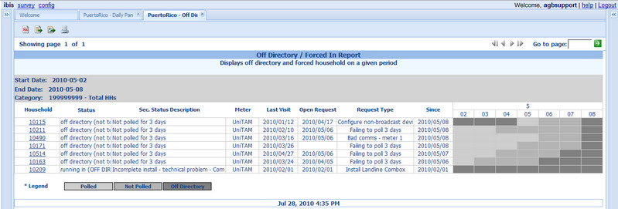

**Figure 1: Off Directory Report**

**Off Directory Periodic Trend: ( Key Performance Indicator)**

* The Off Directory analysis for the 6 months average should be checked ONCE a week to understand if the numbers are on the right trend.
* The trend shows if the Off Directory homes are going higher or lower and action should be taken accordingly .

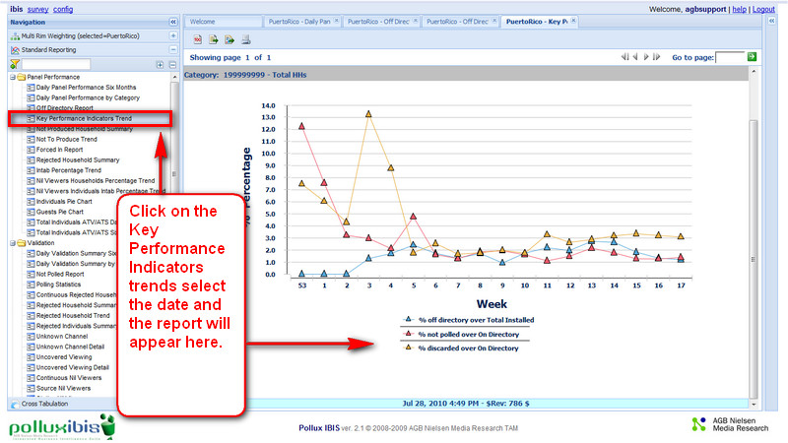

**Figure 2: Key Performance Indicators Trend**

**12.2 Not to Produce Homes**

**Description:**

* Homes that will be polled but will not be part of the produced homes.
* The status is To Poll and Not To Produce.
* These homes are set as Not To Produce homes for various reasons such as:

                                             - Continuous high Uncovered Viewing

                                                     - Continuous high Unknown Channel

                                                     -  New homes on trial period

                                                     - Technician visited home for maintenance

**Reasons Why?**

* When there is a new home installed, it must be set as status Not To Produce (On Trial) for a maximum of one week for the panel to get acquainted to the meter and push button procedures.
* When there is a change of meter type in an existing home for example from TVM2 to TVM5 or UniTam, the individuals in the panel need to be given sometime to familiarize themselves with the new meter.
* Homes with continuous Unknown Channel and Uncovered Viewing for a period of more than 3 days should be set on a Not To Produce status.
* Validated Home with high continuous Unknown Channel and Uncovered Viewing should also be changed to status Not To Produce as it the home will not produce a ‘good’ data.
* When a technician has visited a home and done maintenance, the home should be set to status Not To Produce for at least 1 day to avoid to producing partial data or ‘not clean data’.

**Action:**

* For a new installation or meter type change the home must be set to Not To Produce for a reasonable length of time to make sure the data produced is ‘good’ and the family members are familiar with the meter push button.
* If within this period the produced data is bad and has lots of uncovered viewing a contact needs to be established immediately or a technician sent to the home to understand the reason for this.

**How Often to Check Not to produce homes :**

* The Not To Produce homes needs to be reviewed **DAILY.**
* Family should NOT be in Not To Produce for a long duration. The recommended duration a home can be on this status is no more than 3 consecutive days (This may differ according to countries and secondary status).
* A technician should be visiting a home with this status in less than 3 days.
* For an on trial home this status should be maintained no less than 3 days.
* The recommended duration for an on trial home is around 1 week depending on the data produced and how the family is getting acquainted to the equipment.

**Not to Produce Household Summary:**

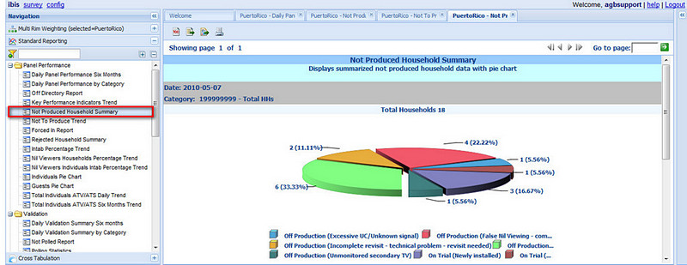

**Figure 1: Not Produced Household Summary Pie Chart**

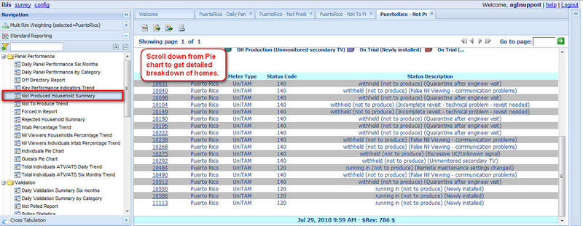

**Figure 2: Not Produced Household Breakdown by Panel Home**

**12.3 Not Polled Homes**

**Description:**

Homes that were not successfully polled or no statement collected due to some reasons.

Reasons for Not Polled homes are:

a) Phone line problem

b) Equipment/meter faulty

c) Service Provider technical issues

**Reasons**:

* A home can not be polled if the phone line in the home has been disconnected or the family did not pay the phone bill.
* Meter is unplugged from the mains.
* Service interruption by telecom or service provider.
* Polling not attempted because there was not enough time, or enough polling lines attached to Pollux .

**Action:**

* Use Google Map to identify the locations of the Not Polled homes to rule out the possibility of a problem with a service provider.
* Focus on the worst offenders (top of the list) as they have the most consecutive days accumulated.
* Drill down on last night production to understand details of polling attempts.
* Technician must be sent immediately to those homes that have had their phone ring during polling to identify the problem and the home has to be put on an Off Directory status.
* Contact the family to understand if there is a phone line problem or if any of the meters were unplugged.
* For a GSM home, a line test can be done from the office to understand if the problem still exists or if it was just a temporary lack of coverage during polling time .

**How Often? :**

* Not Polled homes have to be checked **DAILY.**
* If the phone is ringing the home has to be set as Not to be Polled home (Off Directory) even its only one day.
* It is recommended to change the home status to Not to be Polled (Off Directory) if the home is consecutively 2 days Not Polled (This of course depends on the panel size and reason for Not Polled).

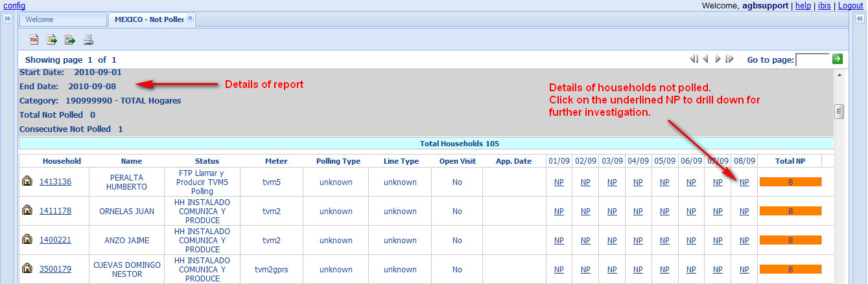

**Figure 1: Not Polled report**

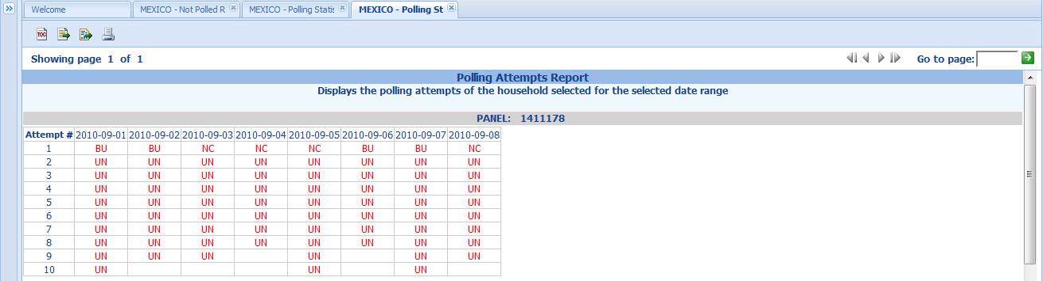

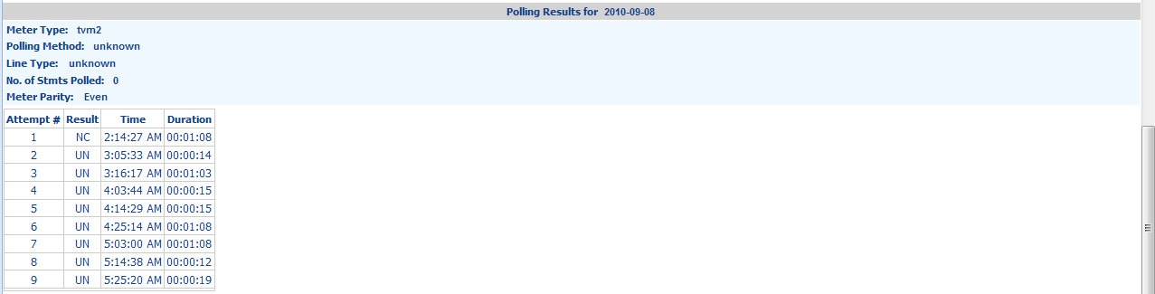

**Figure 2 Not polled - PollingAttempts**

**12.4 Nil Viewing Homes/Individuals**

**Description:**

* Homes/Individuals that did not watch TV the whole day or we collected no viewing statement for the day.
* Nil Viewing (NV) could be caused by:

Real Nil Viewer – home or person who did not watch the TV for the whole day.

  Equipment/meter faulty – False NV.

No Communication between the meters or meters unplugged from mains – False NV.

**Reason:**

* The genuine cases are individuals or family that did not watch TV the whole day. They may have been out of town, on holiday, did not watch TV or their TV set may have broken.
* False Nil Viewers are not genuine Nil Viewers, reasons for False nil viewing is the BU and TU not communicating.
* In some cases False Nil Viewer is generated due to ‘third party interference’ such as unplugging the meter or changing the meter cabling.
* False Nil Viewer (family/TV set) is also generated by new TV set not metered yet. Family is watching but no data is retrieved.
* Nil Viewing Individuals can also occur due to lack of education where the wrong push button is pressed or they are not pressing any button at all.

**Action:**

* Use the Continuous Nil Viewers reports (HHs,Individuals and TV Sets).
* Try to establish the reason for the Nil Viewing first and then take action based on that.
* Focus on the worst offenders (top of the list) as they have the most consecutive days accumulated.
* If there is a home with a main TV set broken then contact them to find out when it will be fixed and record the information in the family notes for future reference and checks. This is real nil viewing as they cannot watch a broken TV.
* If it is caused by an unplugged meter, call the home to check if anyone could have moved the cables or unplugged the meter. If the household member does not know how to fix it, send a technician and set the home to Not to produce status until the problem has been fixed.
* For Individual nil viewing, call the home and understand if they really did not watch TV. It may be that the individual has moved out from the house or has gone abroad for studies. In this case the member status has to be updated.
* Quite often it is an individual that didn’t press the button. Individual Nil Viewing analysis allows you to spot lazy viewers that can generate UV if watching alone. The individual must be re-educated and monitored and if the problem persists the household must be dropped.

**How Often?:**

* HHs Nil Viewer have to be checked **DAILY.**
* False Nil Viewer have to be tackled promptly.
* A home or member who is Nil Viewer for more than 3 (5 days for homes, 15 for individuals) days has to be contacted to understand the reason. (This depends on the panel size and the reason for Nil Viewing)
* For TV Set Nil Viewing 2 times per week would be the recommended QC checks.

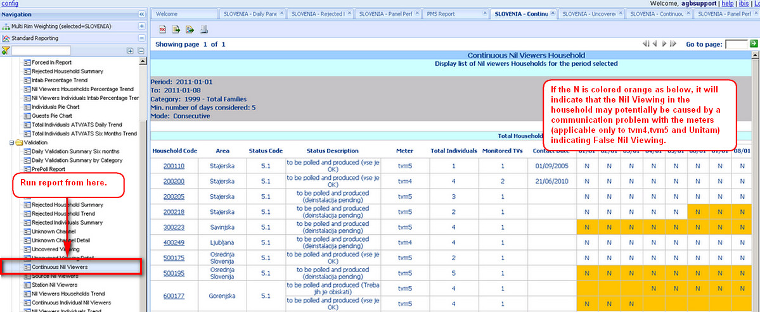

**Figure 1:Continuous Nil Viewer Report**

**12.5 Rejected Homes**

**Description:**

Homes that are rejected by production can be caused by a number of reasons.

The main reasons for a home to be rejected are:

•                Uncovered Viewing (UV)

•                Unknown Channel (UC)

•                Time Drift (TD)

•                Others: Prevalidation, invalid data capture, invalid statements, constant viewing 24hrs, unknown TV set.

**Action:**

•         **IBIS** has several reports to understand the validation process and those households that failed. Users could start with

▪  Daily Validation Summary 6 Months which provides a view of the rejection levels on the last 8 days.

▪  Rejected Household Summary to get the list of households rejected in a single day (perhaps last night production results).

▪  Continuous Rejected households, it is the best report to spot households with recurrent problems (worst offenders). Besides gives you a holistic view of the validation results of the households (not only the rejected ones

* Focus on the worst offenders (top of list) as they have the most consecutive days accumulated.
* Write the conclusion of your analysis at the family notes for future reference and check
* If it is caused by technical problem, send a technician and set the home to Not to produce status until the problem has been fixed.
* For behavioral related issues (such as lack of cooperation) try to  re-educated the family members and monitored them closely. If the problem persists the household must be dropped.

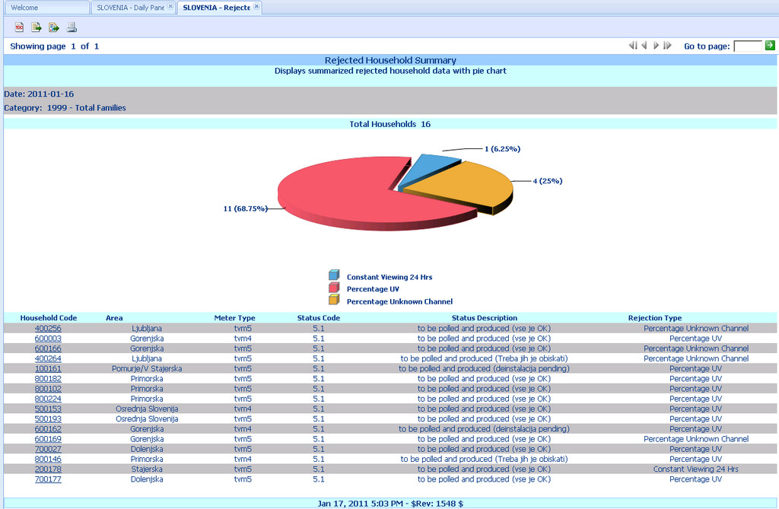

**Figure 1: Rejected Household Summary**

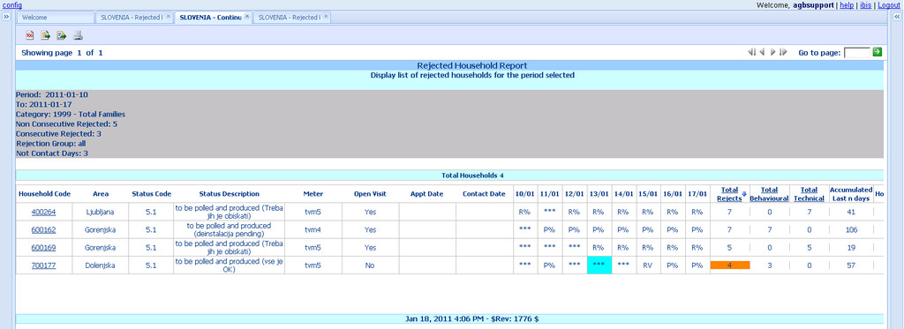

**Figure 2: Continuous Rejected Report**

**How Often?:**

* All rejected homes have to be checked **DAILY.**
* However it’s also best to check the rejected homes on consecutive days to tackle the worst performing homes.
* Call or send a technician if the home has rejected for 3 days consecutively.
* Those homes that cannot be fixed within the 3 days have to be taken out of production.

**Additonal Notes:**

* Use drill down to Panel Performance History (PPH) to understand how the HHs performance was for the past 5 weeks.
* Examine the statements by drilling down from PPH .
* It is extremely important to make sure all contact with the households are written into the Pollux Contact Page for future reference and theTechnician visit page is updated.
* **DO NOT** use the Technician Management page to record the past visits, use it as a planning tool.

**12.6 Rejected Uncovered Viewing**

**Description:**

Uncovered Viewing arises when a television is switched on without any household members logged on.

Uncovered Viewing can be due to either technical or behavioural problems .

**Reasons:**

The main reasons for UV:

* Problem with the Base Unit (BU)
* Problem with the Handset either broken or flat battery.
* Behavioral issue such as poor push button practice.
* Lack of cooperation or lack of knowledge.
* Poor training from the technicians.

**Action:**

* For UV homes, analyze first the home viewing to identify who is not pressing the push button and precisely at what time.
* Check to see if the person has been disabled in the HHM and why.
* If someone has wrongly pushed the button educate them on the proper way to do it.
* **DO NOT** call the family and ask them why they did not push the button before having checked if the UV is caused by a non-valid individual or concurrent viewing.
* Make sure the person who is calling the family has all the details at hand first before calling and talking to the family. Information such as the trend of UV for the previous few days is also important. When speaking with the panel member always refer to the data from the day before.
* If the UV happens always in the morning, try to call in the morning as the chances of getting the ‘offender’ will be higher.
* If a home has 100% UV most probably the remote control unit is broken or the battery is flat or the BU is not registering the individuals. Contact the family to understand and send a technician if this is the case.

**How Often?:**

* All rejected homes have to be checked **DAILY.**
* However its also best to check the rejected homes on consecutive days to tackle the worst performing homes.

Call or send a technician if the home has rejected for 3 days consecutively.

* Those homes that cannot be fixed within the 3 days have to be taken out of production.

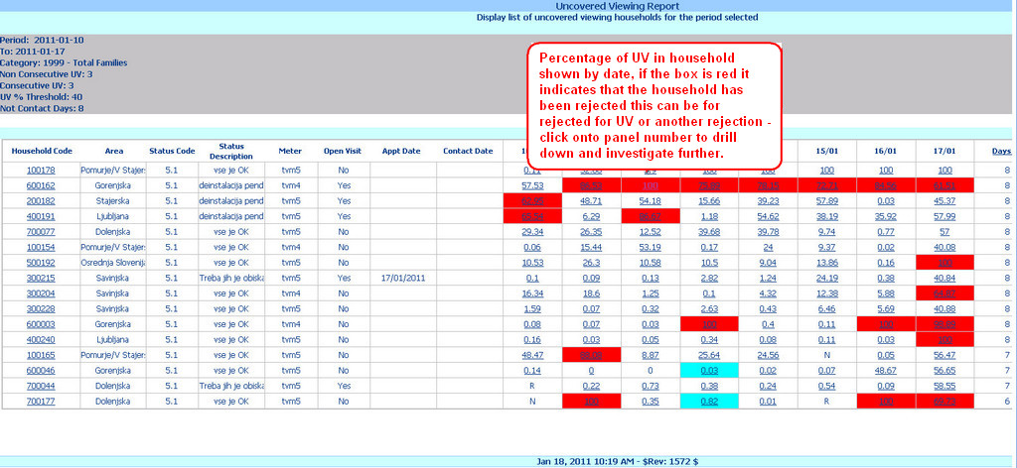

**Figure 1: Uncovered Viewing Report**

**12.7 Rejected Unknown Channel.**

**Description:**

Unknown Channel (UC) happens when a channel or frequency could not be recognized by the meter or could not be located in the channel map (either in the meter or Pollux HHMaster file)

**Reason:**

The main reason for the UC:

* Corrupted channel map
* Pick up/cable being disconnected
* New device which is not registered in HHM
* Changes in channel line up
* New channel not inserted during the installation
* Association channel/station missing in HHM (or Channel Map configuration files)

**Action:**

* For UC homes, call the home to understand if there is any pick up
* or cable disconnected.
* Check if there is a new device in the house and contact the family.
* Send a technician immediately to do the changes to the channel line up if necessary.
* If a technician is not available change the home status to Poll and Not to Produce.

**How Often?:**

* All rejected homes have to be checked **DAILY.**
* However its also best to check the rejected homes on consecutive days to tackle the worst performing homes.
* Call or send a technician if the home has rejected for 3 days consecutively.
* Those Homes that cannot be fixed within the 3 days have to be taken out of production.

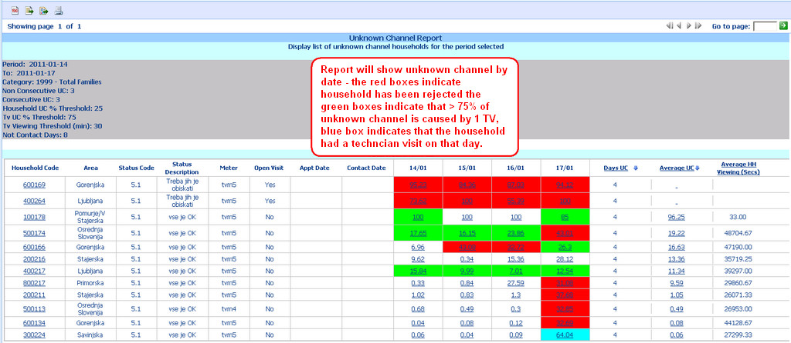

**Figure 1: Unknown Channel Report**

**12.8 Validated Uncovered Viewing**

**Description:**

Validated homes that have high percentage of Uncovered Viewing (UV).

**Reason:**

* The reasons are the same for homes that have rejected Uncovered Viewing.
* Although the Validated UV homes are not rejected it is important to address these homes immediately as the chances of these homes becoming rejected are high.
* By lowering the UV it will increase the viewing delivered to the market and lower the quantity of families that may possibly be rejected. Its like a ‘double benefit’.

**Action:**

* The same actions should be carried out for the Validated UV as for the Rejected UV.
* Investigate the reason for the UV and if behavioural re-educate the home on the importance of using the handset.
* A good and convincing approach should be used to educate the family.

**How Often?:**

* Analyze these homes **DAILY**.
* The more often these problems are tackled, the less UV will exist .

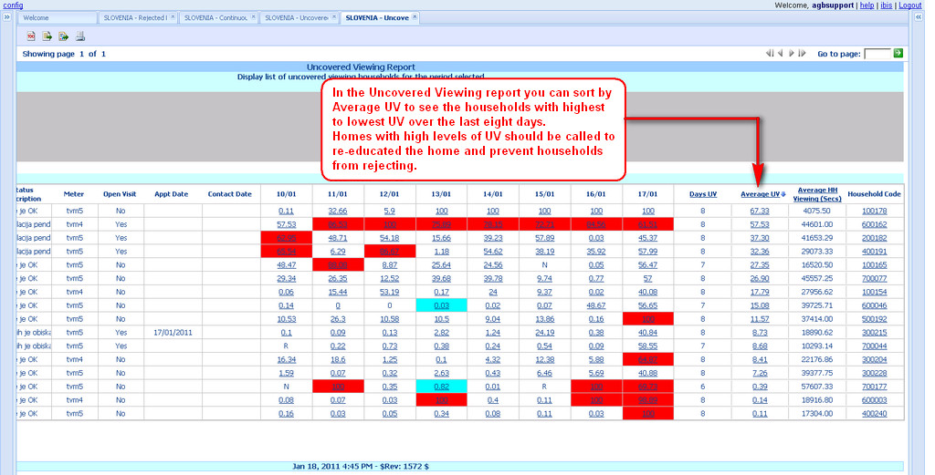

**Figure 1: Uncovered Viewing Report - Average UV.**

**12.9 Validated Unknown Channel**

**Description:**

Validated homes that have high percentage of Unknown Channel (UC).

**Reason:**

* The reasons are the same for homes that have rejected Unknown Channel. A Meter related issue or invalid source .  Missing channel map or disconnected probe.
* Although the Validated UC homes are not rejected it is important to address these homes immediately as the chances of these homes becoming rejected are high.
* By lowering the UC it will increase the viewing delivered to the market and lower the quantity of families that may possibly be rejected. Its like a ‘double benefit’.

**Action:**

* The same actions should be carried out for the Validated UC as for the Rejected UC.

**How Often?:**

* Analyze these homes **DAILY**.
* The more often these problems are tackled, the less UC will exist.

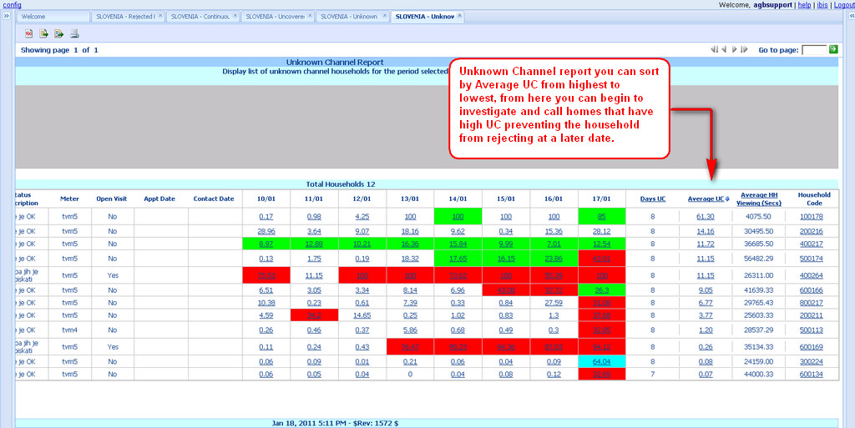

**Figure 1: Unknown Channel Report - Average UC**

**12.10 Quality Control Procedures Summary**

**Summary and Important points**

•         Good training of panel households is essential for the success of your panel. The initial training that the technician provides is the most important and effective one as it’s done face-to-face.

•         It’s good to review the training provided by the technicians to see if what has been transmitted to the panel households is correct and valid. This will become evident while running the quality control checks and same patterns are found on panels attended by the same technician. However, re-training is suggested to all technicians every year, so they could be updated on new arising issues (patterns), QC procedures and to share among team member’s best practice and benchmarks.

•         When the technician is at the panel household, take this opportunity to perform a full “preventative maintenance” (other things that may require attention). All meter related equipment (and accessories) must be checked.

•         The Research Assistant need to deeply analyze the exception (e.g. rejected households, not polled, etc) before calling or sending the technician to the panel. Some exceptions could be fixed internally, moreover a clear understanding of the problem leads to quicker interventions and long term solutions.

•         Give as much information to the technician and be precise on what they have to fix. For example what is the reason of the rejection and what is causing the unknown channel. All this information will be very useful to the technician.

•         The Technician must give good feedback on what has been found to be the problem and what has been done at the panel household, so appropriate records can be inserted into HHMaster for future references.

•         Contact page and Technician Management needs to be fully used.

•         It is extremely important to use the Secondary Status for Family and TV sets. The secondary status will further explain on the main status and makes easier to analyze and to understand a panel household.

**13. Rim Weighting**

**13.1 Rim Weighting**

For those operations that have more than one Pollux environment (such as tests environments, to validate “on trial households”, parallel productions or platforms),  IBIS provides the capability to choose the environment to run the reports from.

A single environment has been selected as default, so every time users login into IBIS, it goes straight to that reporting environment (main or QC environment). If the default environment is not the correct one and/or you wish to change it, please contact the Pollux Product Manager to adjust it.

The default environment name is always displayed at the “Multi Rim Weighting” item (at the top of the Navigation Menu or left pane). If users wish to select another environment, then open the menu to select among the available items (environments).

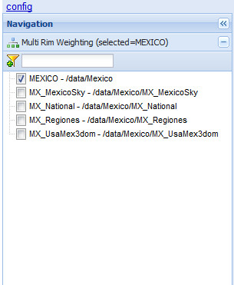

**Figure 1: Multi Rim Weighting menu**

Rim Weighting Reports:

* Goal: Understanding weighting results.
* Frequency: **Every Day.**
* Attention to the conditional formatting to spot issues with the panel .

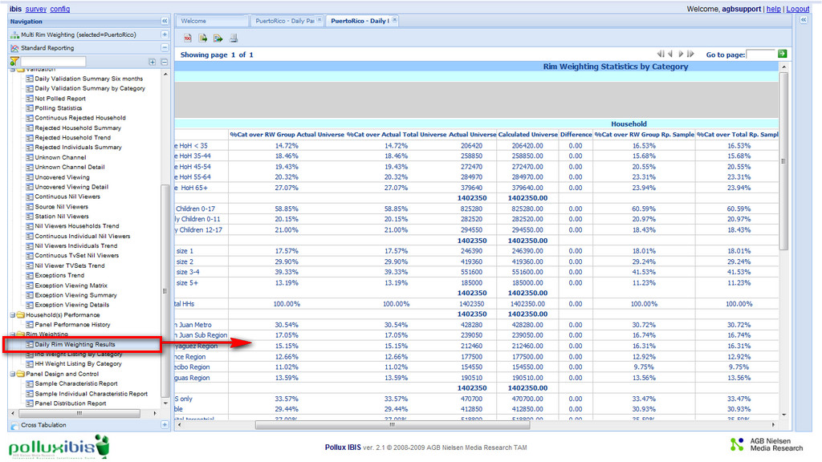

**Figure 1: Daily Rim Weighting Results**

* Review Rim weighting results
  + Categories by groups

* + Family and individuals results on same report
  + Drill down
    - Families – Individuals by Category
    - Categories where Family – Individuals belong too

* + Equivalent Sample ~ RW efficiency in terms of HHs
  + Conditional formatting
    - Minimum reporting sample
    - Minimum and Maximum weight

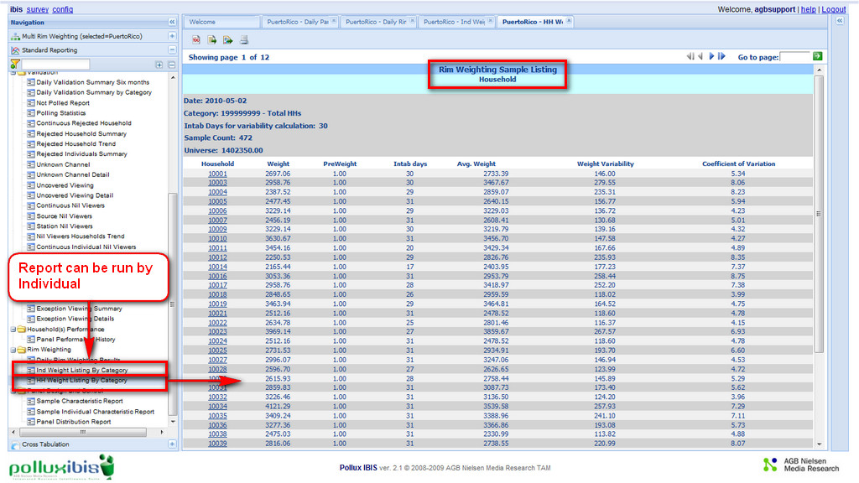

**Figure 2: Rim Weighting by Household**

**13.2 Rim Weighting - Algorithms**

Rim weighting efficiency

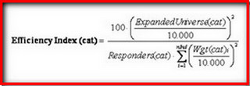

 Cat= category

 Nind=number of individuals

 Weighting Variability (standard deviation)

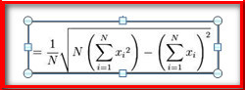

N = total number of days (intab) so usual 30

i  = day i

Xi = weight in day i

**Coefficient of variation**:

(*Standard Deviation / mean of the weights)*100*

It is an index and can be easily and correctly used to compare families / individuals because scale invariant.

It will compare the variation of the weights in the same type of scale,those families/individuals who have the bigger CV are more affected by the variation of their weights and should be taken under control, as any variation of their weights will have a significant impact on the weights of all categories that they belong to.

**14. Report Definition - Colour schemes**

**14.1 Colour schemes**

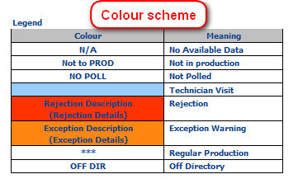

**Table 1: Colour Scheme definitions**

Light Blue = Technician Visit

Orange =

* PPH: exception HHs It is about to be rejected (67% ~ 99% of the threshold to be rejected)
* Continuous Rejected; Uncovered viewing & Unknown Channel : 3 or more consecutive days without a contact registered
* Continuous Nil: False nil viewer
* Detail UV/UC: Longest statement
* Rim Weighting Details: Max Weight

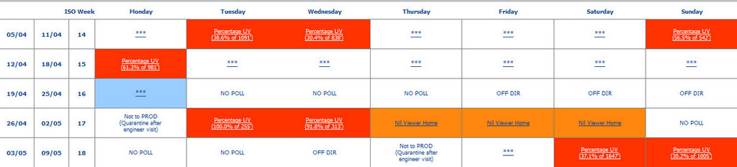

**Figure 1: Example of colour scheme in the Panel Performance History 5 week view**

* Green:
* Unknown Channel: > 75% UC in a TV.
  + Detail UV/UC: consecutive statements.

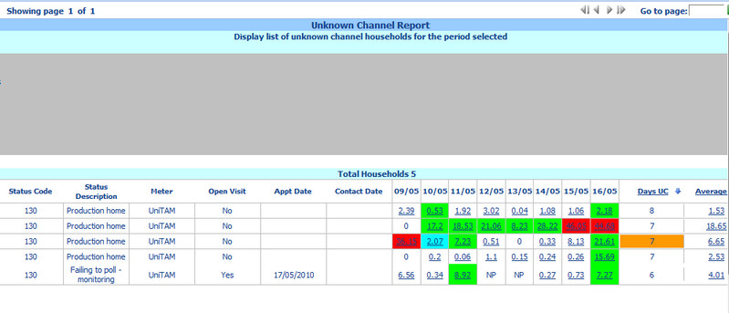

**Figure 2: Example of colour scheme in the Unknown Channel Report**

* Yellow:
  + Rim Weighting: Max and Min Weight.
  + Rim Weighting Details: Min Weight.

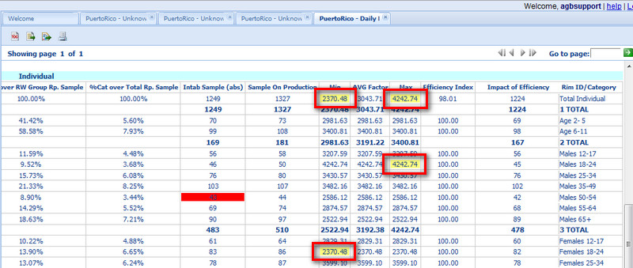

**Figure 3: Example of colour scheme in the Individual Rim Weighting Report**< /SPAN >

**14.2 Polling colour scheme**

**Polling colour scheme:**

Light Gray: On Directory – Polled.

Medium Gray: On Directory – Not Polled.

Dark Gray: Off Directory.

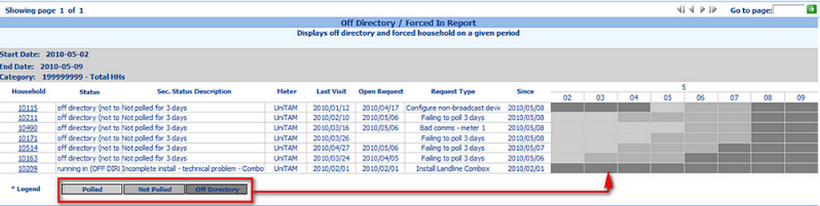

**Figure 1: Example of colour scheme in the Off Directory Report**

**14.3 Continuous HH rejection report definitions**

In the Countinous HH Rejection report the below letter codes are used to describe the rejection type, you can also hover over the letter in the report for a pop up window to explain the letter codes.The Count In column shows which group the reject will be added to.

|  |  |
| --- | --- |
| **Rejection Type** | **Count In** |
| RL = Reject for [L]azy Viewing TV | Behavioral |
| RP = Reject for Single Uncovered Period | Behavioral |
| RT = Reject for Total Uncovered on TV | Behavioral |
| RO = Reject for Total Uncovered. Viewing | Behavioral |
| P% = Reject for Percentage UV | Behavioral |
| RE = Reject for Time Error | Technical |
| RD = Reject for Invalid Data Capture | Technical |
| RS = Reject for Invalid Statement | Technical |
| RC = Reject for Unidentified Channel | Technical |
| R% = Reject for Unidentified Channel | Technical |
| PB = Reject for Play Back | Technical |
| RR = Reject for recording on VCR | Technical |

|  |  |
| --- | --- |
| DPRF = Reject for Prevalidation | Only in Total Rejects |
| RV = Reject for Constant Viewing | Only in Total Rejects |
| RI = Reject for Invalid MDU | Only in Total Rejects |

**Table 1: Letter coding for the Continous HH rejection report.**

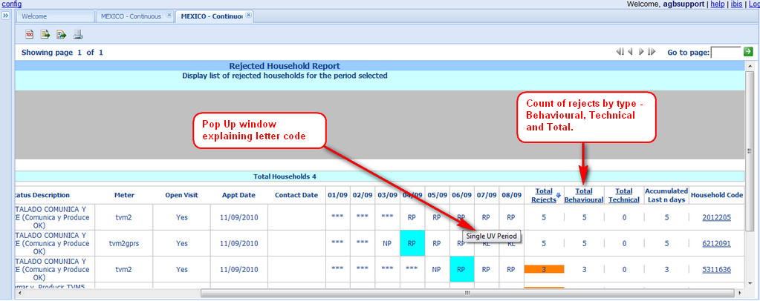

**Figure 1: Continuous Household Report.**

**15. Report Descriptions**

|  |  |  |  |
| --- | --- | --- | --- |
| **Report** | **Parameter** | **Default** | **Remarks** |
| Daily Panel Performance  (DPP)  Daily Validation Summary (DVS) | End date  Category | Last night + 8 back dates  Total Households | Insert end of the period date; start date will be calculated |
| Daily Panel Performance by category  (DPPC)  Daily Validation Summary by Category (DVSC) | Start date  Category Group | Last night  Selected category group. All categories within the group will be displayed | Any other day selected from DPP or DVS.  Categories groups should be created before hand. |

**15.1 Main Panel Parameters**

|  |  |  |  |
| --- | --- | --- | --- |
| **Report** | **Parameter** | **Default** | **Remarks** |
| Daily Panel Performance  (DPP)  Daily Validation Summary (DVS) | End date  Category | Last night + 8 back dates  Total Households | Insert end of the period date; start date will be calculated |
| Daily Panel Performance by category  (DPPC)  Daily Validation Summary by Category (DVSC) | Start date  Category Group | Last night  Selected category group. All categories within the group will be displayed | Any other day selected from DPP or DVS.  Categories groups should be created before hand. |

**15.2 Panel Performance History Parameters**

|  |  |  |  |
| --- | --- | --- | --- |
| **Report** | **Parameter** | **Default** | **Remarks** |
| Panel Performance History | End Date  Household code | Last night + 5 weeks back |  |
| MPI Statements  PMS Statements  SV Statements | End Date  Household code  Start / End Time |  |  |

**15.3 1 Day List/Pie charts Parameters**

|  |  |  |  |
| --- | --- | --- | --- |
| **Report** | **Parameter** | **Default** | **Remarks** |
| Off Directory  (HHs summary list)  Not Produced HH Summary  Individuals Intab Summary  Guest Produced Summary  Rejected HHs Summary  Rejected Individuals Summary  Discarded Viewing from Validated HHs | Start date  Category | Last night  Total Households | Any other day selected from DPP or DPPC |

**15.4 Polling reports Parameters**

|  |  |  |  |
| --- | --- | --- | --- |
| **Report** | **Parameter** | **Default** | **Remarks** |
| Not Polled | End date  Category  Non consecutive NP  Consecutive NP | Last night + 8 back dates  Total Households  0  1 | It will provide a list of ALL HHs Not Polled from last night. These two parameters work as an “OR” mode.  Same results will be given with 1;2. |
| Polling Statistics | Panel |  | Panel number |

**15.5 Continuous Rejected Reports Parameters**

|  |  |  |  |
| --- | --- | --- | --- |
| **Report** | **Parameter** | **Default** | **Remarks** |
| Continuous Rejected HHs | End date  Category  Accumulation period  Rejection Type | Last night + 8 back dates  Total Households  365  All | Accumulated period,  when available otherwise the average of the period up to the threshold.  It is a sort threshold. 3 options available: ALL (both at the same time), Behavioral orTechnical. |

**15.6 Nil Viewing report Parameters**

|  |  |  |  |
| --- | --- | --- | --- |
| **Report** | **Parameter** | **Default** | **Remarks** |
| Continuous HH/Individuals/TVSets Nil Viewers | End date  Category  Min Nil Viewer Days  Mode  Accumulation Period  Include Individuals belonging to HHS Nil * | Last night + 8 back dates  Total Households  5  Consecutive  365  No | No consecutive mode is also available.  Accumulated period,when available otherwise the average of the period up to the threshold. |

|  |  |  |  |
| --- | --- | --- | --- |
| Source Nil Viewers | Start & end date  Category  Min Days  Source List | Last night + 8 back dates  Total Households  5 | Min. amount of days to be considered in a period.  Look up list with all active source. Multiple selection is allowed. |

**15.7 UV and UC report Parameters**

|  |  |  |  |
| --- | --- | --- | --- |
| **Report** | **Parameter** | **Default** | **Remarks** |
| Uncovered Viewing  Unknown Channel | End date  Category  Threshold Days  Non Consecutive UV/UC  Consecutive UV/UC  UV/UC Threshold  *Total TV Viewing (min) | Last night + 8 back dates  Total Households  8  3  3  10  0.0 | Min. amount of days to be considered in a period.  Percentage of UV to be considered.  Total viewing validated. |

**15.8 UV and UC Detail Report Parameters**

|  |  |  |  |
| --- | --- | --- | --- |
| **Report** | **Parameter** | **Default** | **Remarks** |
| Uncovered Viewing – Detail  Unknown Channel - Detail | End date  Household code  Start time  End time | Last night  02:00:00  25:59:59 | Any other day selected from UV report  Automatically transferred from UV report.  Other code could be manually inserted  Standard Pollux start and end date time |

**15.9 Forced In Report Parameters**

|  |  |  |  |
| --- | --- | --- | --- |
| **Report** | **Parameter** | **Default** | **Remarks** |
| Forced In | Start & end date  Category  Since n number of days  Show history since in days | Last night + 8 back dates  Total Households  30  365 | Families with at least 30 days of Forced In  Count of days on: Forced In, To be polled, Polled and Not Polled for the last 365 days |

**15.10 Trend report Parameters**

|  |  |  |  |
| --- | --- | --- | --- |
| **Report** | **Parameter** | **Default** | **Remarks** |
| Key Performance Indicators Trend (Off Directory; Not Polled; discarded)  Not To Produce Trend  Intab Percentage Trend  Nil Viewers HH/ Individuals Intab % Trend | End date  Category | Last night + 6 months back  Total Households | 6 months back data when available otherwise the average of the period up to 6 months. |

|  |  |  |  |
| --- | --- | --- | --- |
| Total Individuals ATV /ATS Daily Trend  Total Individuals ATV /ATS 6 Months Trend  Rejected HHs Trend  Nil Viewers HHs / Individuals / TV Set Trend  Exceptions Trend | End date  Category | Last night + 6 months back  Total Households | 6 months back data when available otherwise the average of the period up to 6 months. |

**15.11 Rim Weighting Report Parameter**

|  |  |  |  |
| --- | --- | --- | --- |
| **Report** | **Parameter** | **Default** | **Remarks** |
| Rim Weighting | HH Min Sample  Ind Min Sample | 20  40 | Conditional formatting to highlight minimum reporting sample by category |
| Weight Listing By Category for Individuals or Families | Days for variability | 30 |  |
| Category List | Household number |  |  |

**Editor Layout**

Scheduler Editor is divided into four main areas:

* **Jobs**: Details of all the jobs the Scheduler has to manage. A job is a set of Actions (e.g. run a report) to execute all together at a specific time.
* **Delivery Method Options** Each Job can specify a different method to report the results of its Actions. At the moment only SMTP method is implemented.

Delivery Method Options area allows you to configure all the parameters specific for the chosen method.

* **Actions**:This area lists all the Actions the selected Job has to execute when it runs.
* **Parameters**: In case the Action is run a report, the report requires that it's parameters have to be set. This area allows you to specify how to set these parameters.



**Figure 1: Scheduling Configuration Main Page**

**18. Reports**

**18.1 Sample Characteristic Report**

The aim of this report is to have the sample characteristics of the panel listed on a daily basis. The report should be run within a specified environment and category groups selected using Configuration Tool – Category Groups.

The advantage of this report is to be able to compare the panel Ideals, with current installed, "on production" and "Intab levels" as well as with the current universes (Rim Weighting or calculated universes as per the sum of all households belonging to the category), providing a clear picture of all important "day to day" panel variables with the proportions or disproportions to the universes, so corrections on panel balances can be better understood.

|  |  |
| --- | --- |
| **Field Name** | **Meaning** |
| Environment | Production Environment |
| Category Code | Category code used as filter: Any Households or Individuals that belong to the category will be part of the report. Default is Total Family (recommended) |
| Category Name | Description of category used as filter in the report |
| Panel Control  Variables | Groups of Categories used to control the sample. Groups Highlighted in grey are used in the weighting process. |
| Ideal | Ideal number of installed homes. |
| Installed | Count of households with status installed. |
| Inst Unwtd % | Percentage of Installed Households or Individuals in that specific category over the Total installed. |
| On Prod | Count of Households or Individuals to be produced before apply the editing/validation rules. |
| On Prod Unwtd % | Percentage of Households or Individuals to be produced in that specific category over the Total produced. |
| Intab | Count of Households or Individuals that are successfully validated or "forced in" and will be reported in the final data. |
| Intab Unwtd % | Percentage of Intab in that specific category over Intab total. (Individual or Households) |
| Sum of Weights | The sum of all weights of all households or individuals belonging to the category |
| Intab Wtd % | Percentage of sum of weights of Individuals or Households in a specific category over the total sum of weights. |
| UE | Universe of the category. |
| UE % | Percentage of the category's universe over the total universe (either total Households or total individuals) |
| Total | Total per column of number of households, percentage or weights |
| Intab % | Intab percentage of either On Production or Intab sample over Total Installed |

**Table 1: Sample Characteristic Report Headings**

The report can be run either for: Family (primary controls) or Individual (secondary controls).

• The categories to be included in the report must be selected using the "Category Group" tool (please see IBIS Help File – Configuration Tool, for how to set up the groups).

• The report can include or exclude the newly installed "on trial" households (by default included).

• Universes values are automatically uploaded from Pollux.

• Panel Ideals are uploaded during the configuration of IBIS. If any modification is required, please contact Pollux Product Manager

• Tolerance levels for installed households (in relation with panel ideals) are automatically calculated. The standards are:

|  |  |
| --- | --- |
| **Nielsen Internal Tolerance Rules** | |
| Ideal of 1-10 homes | +/- 1 HH |
| Ideal of 11-50 homes | +/- 10% |
| Ideal of 51-100 homes | +/- 8% |
| Ideal of 101+ homes | +/- 6% |

**Table 2: Tolerance Rules**

Users can execute the report using other sets of variables as the tolerance levels are parametrical, therefore accessible via the parameters window or right pane.

Conditional formatting can be applied:

•         Highlight in Red if tolerance is exceeded negative/positive.

•         Highlight orange if tolerance is 80% of its value negative/positive.

At the tree menu the report is located under Panel Control and Design directory.

**Some Recommendations:**

•    It should be run once per week on those panels (or variables) that are well balanced; and more often for those which are in process of balance or turn over period.

•    Those variables that are out of tolerance should be prioritized high, not only for panel balance purposes but also at “maintenance level” focusing resources to recover those households out of “intab”.

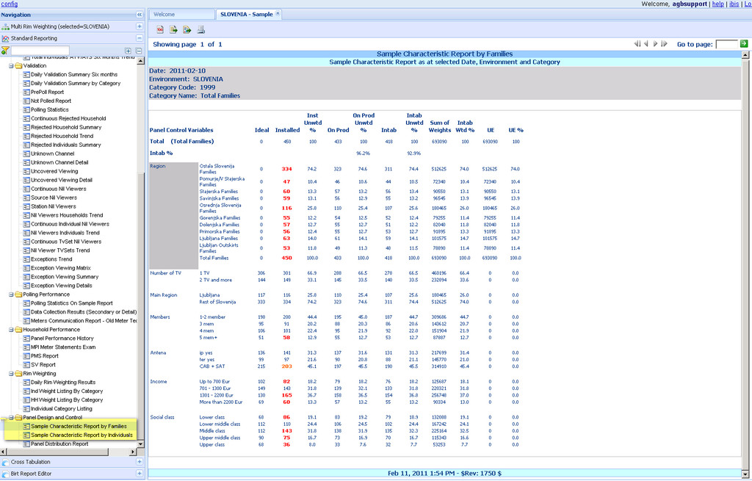

**Figure 1: Sample Characteristic Report**

**18.2 Panel Distribution Report**

The objective of the Panel Distribution report is to display the current distribution of the installed households as well as to forecast possible changes on the next X days.

 The report is able to be run within a specified environment and category group selected from Configuration Tool – Category Groups.

As the “Sample Characteristic Report” users are able to compare the panel ideals with current installed level, and “Intab levels” on the last 7 and 28 days.

 The most striking characteristic of this report is its ability to forecast changes on the panel composition for the next 7 days counting homes that will be incorporated to the production after the on trial period is over, deinstalled households due to known turnover (forced, natural, or suspended), and scheduled installations (with appointment already established). Based on all these factors, the system calculates the category (s) that requires any effort for balance and will provide the users with the priority level on each category, so resources can be well planned.

Variables or key elements included in the report:

|  |  |
| --- | --- |
| **Field Name** | **Balloon** |
| Category Group | Description that identifies the group to which the category belongs to. |
| Category Description | Description given to the category, it should be descriptive of its content. It is as per File Maintenance - Category file |
| Max Panel Ideal | Maximum number of households that should be installed on each category.  Panel ideals are uploaded during the configuration of IBIS. If any modification is required, please contact [Pollux Product Manager](mailto:fatima.abreu@nielsen.com) |
| # of HHs Tolerance | Tolerance Level allowed for the category without incurring on any penalties. The minimum number of households to be installed should be Max Panel Ideal minus the tolerance level. |
| Actual HHs Installed "End Date" | Count of households installed in the sample on a given day (End date). Actual households Installed at “End Date”. It is configurable as some operations might want to exclude "Poll not to produce households" that are "on trial period". Default "all" households installed are included (even those on trial). |
| % Installed Over Ideal | Calculated value. Percentage of households installed over the ideal. |
| % Inst | Percentage installed: Percentage of the category's households installed over the total households installed within the group |
| % UE | Percentage Estimated Universes: Percentage of the category's universe over the total universe of its RW group. This figure is the same as %UE from Sample Characteristics Report. |
| Category X1 Days Intab | Average Intab level of the category over the last X1 days. Default is 7 days (backwards) from "End Date". |
| Category X2 Days Intab | Average Intab level of the category over the last X2 days. Default is 29 days (backwards) from "End Date" |
| Known Changes - Pending On Trial | Count of Household on status "to Poll not to produce" due to "on trial period". Only count households on trial that have been installed in the Last X days from "end date". Default is 7 days.  The “On Trial” condition is identifying by a specific status that separates the “on trial” from other type on “to poll and not to produce”. If you need to add a new status, please contact [Pollux Product Manager](mailto:fatima.abreu@nielsen.com) to coordinate the modifications. |
| Known Changes - Net Aging | Count of households that will change from one category to other as consequence of demos update related to age. Change that will happen on the next X days from "end date". Default will be 7 days from "End Date"  Net aging could mean a positive or negative outcome. Cell with "Negative" net will be colored in red. Configurable from "Data Integrity Tool", active by default.  Example: Age of HOH (age of the head of household) when that person change from 34 to 35 or 54 to 55 years old. Presence of kids when the youngest kid of the households pass from 17 to 18 years old. |
| Known Turnover | For all categories only consider those households with appointment date set to X days. Default will be 7 days from "End Date" |
| Known Turnover - Susp. | Suspended: Count of HHs that has been on status "Off Directory" more than X days consecutive from "End date" counts backwards. And any households on status "Off Directory" with secondary status "pending drop out" regardless the number of days on those status. Default will be 60 days  Add any HHs on status "Off Directory" with secondary status "pending drop out" regardless the number of days on those status  If you need to add a new secondary status, please contact [Pollux Product Manager](mailto:fatima.abreu@nielsen.com) to coordinate the modifications and to adjust the ETL process accordingly. |
| Known Turnover – Forced | Count of households whose secondary status is "force turnover" or "Normal Turnover" that will be deinstalled on the next X days from "End Date". Default 7 days. |
| Known Turnover - Normal | Count of households that have an 'open visit' and appointment date with request type "households to be desintalled" regardless the main status AND HHs with main status "pending to drop out or desintalled" within X days. Default will be 7 days from "End Date"  The open visit type and the status are configurable. Please contact [Pollux Product Manager](mailto:fatima.abreu@nielsen.com) to adjust the ETL process accordingly. |
| Pipeline - Net # Installed | Calculated value. Actual installed + Pending On Trial -/+ Net Aging - Known Turnover |
| Pipeline - Net % Inst | Percentage of the category's Net installed over the total Net installed group |
| Schedule Installation X Days | Count of households recruited and with installation booked over the next X days. Visit type = Installation and Appointment date from End Date up to X days. Default 7 days |
| Ideal - Net Installed | Calculated value. Difference between "Panel Ideal" - "Net Installed" |
| Net Inst / Ideal | Calculated value. Net Installed divided by Panel Ideal |
| Preliminary Structured  Prioritization Rank | Calculated value. The highest percentage (column Actual/target) will get then highest rank, the lowest percentage (column Actual/target) then the lowest rank. |
| # Consecutive Weeks out of Ideal | Count of consecutive weeks since this category has not reached the "Panel Ideal". The count gets reset if the Panel Ideal is reached at least 1 day |

**Table 1: Panel Distribution Table Headings**

* Ideally, this report should be used at “Family level”. The default category will be “Total Family”
* Category Group & Categories to be displayed in the report, should be selected and associated to the report using the same methodology as per RIM Weighting, or Sample Characteristics Report, therefore at "Family Category Tool" (please see section Report Type Window at Category Group Tool – page 43 for further details)
* Categories that contain “AGE” components must be marked at the Configurator Tool- Category Group Tool, so the system can understand which categories to take into consideration for this calculation (please see section Report Type Window at Category Group Tool – page 43 for further details on how to set it).
* Tolerance level allowed for any category without incurring on any penalties. The standards applied as per Sample Characteristics  Report (please see page 5: Table 1 - Nielsen International TAM Internal Tolerance Rules).
* The default parameters recommended for this report are:

|  |  |
| --- | --- |
| **Nielsen Standards** | |
| First Intab period (X1) | 7 Days |
| Second Intab period (X2) | 28 days |
| On Trial period (backward) | 7 Days |
| Period where to check Net Aging | 7 Days |
| Period where to find an installation (backward) | 7 Days |
| Period where to find an appointment (forward) | 7 Days |

Users can execute the report using another set of days as they are parametrical, therefore accessible via the parameters window or right panel.

Conditional formatting can be applied (please see section on  Configuration Tool )

Data Integrity Tool for further details on how to set it.

% Installed over ideal:

o   Orange: if percentage is above X1. Default will be 100%

o   Red: If percentage is below X2. Default 80%

  Preliminary Structured Prioritization Rank

o   Rank cells with rank between 1 and 3 could be colored in Green

    # Consecutive Weeks out of Ideal

o   Orange: if number of weeks is above X1. Default will be 8 weeks

o   Red: If number of weeks is above X2. Default 12 weeks

Child or linked report is "**Household Installed Report**" from each cell. The report is filtered by the category selected (please see page 10 for further details).

At the tree menu the report is located under Panel Design and Control directory.

**Some Recommendations**

* It should be run once per week on those panels or sub panels (or variables) well balanced; and more often for those which are on process of balance.
* Please follow the priority recommended by the report to balance first the category with highest priority.

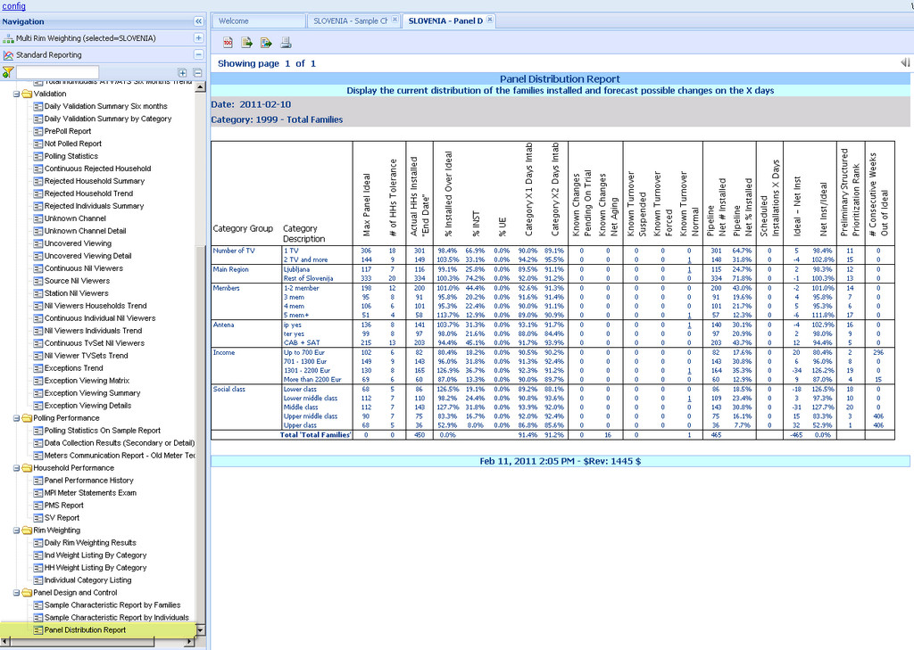

**Figure 1: Panel Distribution Report**

**18.3 Households Installed Report**

The aim of the Household Installed report is to have a detail list of all households installed on a daily basis. It displays some basic family demographics and basic details on panel age and the household performance on the last 365 days.

Variables or key elements included in the report:

|  |  |
| --- | --- |
| **Field Name** | **Balloon** |
| Household Code | Panel Identification number in HHMaster |
| Installation Date | Date the panel was installed (with at least 1 meter and 1 individual) |
| Panel Age | Count of number of months since installation date. Conditional formatting is applied to indicate when the household is over its forced turnover period (input via the config – data integrity tool). The calculation is based on the formula of days 360 (from excel) since installation / 30 days.  Format of the information on the cell = XX (unit numbers without decimals) |
| Area | Geographical area that this household belongs to. |
| Status Code | Household Primary Status numeric code |
| Status Description | Household Primary Status Description and (Secondary Status description) |
| Meter Type | Meter type installed |
| Total Individuals | Count of active individuals (with status enabled (0)) in HHMaster - Individual page By default excludes "Regular Guest or Transient" but it is configurable. |
| Monitored TVs | Count of monitored and temporarily not monitored TV sets (Unit status 0 and 1) in HHMaster - Unit page |
| Last Tech Visit | Last date a technical visit was performed on the HHs. Conditional formatting could be applied if the last visit was performed more than a year ago (default value but configurable) |
| % Days Intab n | Percentage of Intab days over installed days in a period n (365 days as default but configurable).  The formula is % = days Intab / installed days (both values within the period n)  The formula should include the following status: Poll and produced, Poll and not to produce “off production” and “on trial”, Off directory, Not To poll but to Produce, Forced in / Holiday |

**Table 1: Household Installed Report Headings**

 Sort order: Sort HHs with the newest installation date. But also allows dynamic sort on columns:

* Installation date
* Panel Age
* Meter type
* Last Tech Visit
* % Days Intab

Highlight the cells which panel age is bigger than a threshold. This is to highlight households that need to be forced turnover (De-install). The parameter is named forced turnover > n months.

•         Last visit: highlight the cell if the last visit was performed more than a year ago (default). Though range of days is configurable. The parameter named as minimum days without technicians visit > days (since last production date – last night production date). It is counted backwards from last night production date.

At the tree menu the report is located under Panel Performance directory.

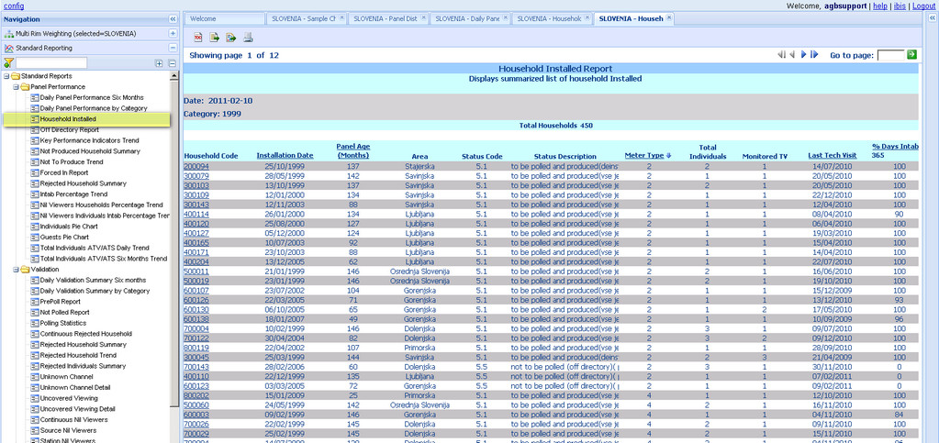

**Figure 1: Household Installed Report**

**18.4 Exception Viewing reports**

The objective of the Exception Viewing Reports is to examine the results of the validation process in detail. It contains information coming from the validation summary and validation details from Pollux Client, and valog (Pollux server / daily directory) of a given day.

The group of exception viewing reports aims to help users to take proactive actions to avoid having the households rejected and to improve the quality of the data delivered to customers. They should be analysed at least twice a week.

It includes 3 reports: Exception Viewing Matrix; Exception Viewing Summary and Exception Viewing Detail, working in a cascade approach to drill down into the information. Access to statement analysis is the last link of the chain.

The main report ”**Exception Viewing Matrix**” contains all exceptions for all households in a single day. The values are in percentage format to facilitate the comparison.

It opens from Daily Validation Summary (DVS) line 7a “% Discarded viewing from validated HH”, 7d “% Total Validated constant viewing” and 7e “% Total long viewing”. Depending on the selection made, the report will be sorted accordingly:

* From 7a “% Discarded viewing from validated HH”, the list is sorted by the households with the highest percentage of Exception Viewing on the top, and as a second option is the highest Total Viewing.
* From 7d "% Total Validated constant viewing", the same conditions as above are applied but the sort of the list will be households with higher percentage of Constant viewing and highest Total viewing followed by households with highest percentage of long viewing and highest Total viewing ( as both exceptions are related). In some opportunities the same households will have both exceptions.
* From line 7e "% Total long viewing", the sort of the list will be households with highest percentage of Long viewing and highest Total viewing followed by households with highest percentage of Constant vieiwng and highest Total viewing.
* It has a dynamic sorting capability where users can re-organize the report by any of the exceptions presented, as well as to select the  direction of the sorting (ascending or descending).

At the top of the report there are a couple of pie charts. The biggest chart displays the distribution of the main exceptions types (Total discarded viewing, Total Uncovered, Total Unknown channel, Constant viewing and long viewing). Absolute and relative values are both displayed.

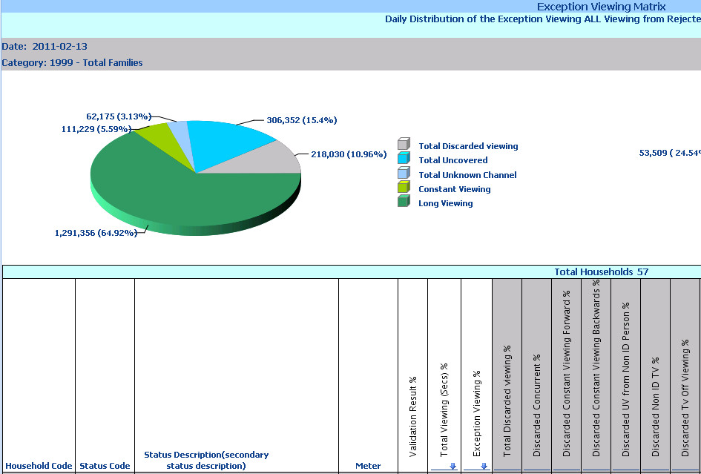

**Figure 1: Exception Viewing Pie Chart**

The second pie chart contains the distribution of reasons for the discard viewing (Concurrent, Constant viewing forward and backwards, UV from Non ID person and TV, TV off viewing, invalid data capture, not valid source rule and No viewing TV off rule).

Variables or key elements included in the report:

* A parameter to include or not the list of households rejected (excluded by default). When listed, households rejected, are highlighted in red as well the reason of the rejection when associated to any of the exceptions displayed in the report.
* The exception viewing column includes a filter to control the minimum percentage of any given exception. It is parametrical and the default is 10% (to exclude households with less than 10% of any exception)
* Total Viewing (in seconds): Total viewing of the family is in absolute values (second based), including viewing from extras such as under age and non viewers button. This is viewing before validation.
* Exception Viewing %: It is the sum of the percentages of all exception viewing = Total Discarded viewing % + Total Uncovered % + UV from No Viewers % + UV from Under age % + Total Unknown Channel %. Percentages from Long and Constant viewing are excluded from this sum, as these could be normal behavior that just required to be checked. This percentage is always calculated over the total viewing of the family.
* Total Discarded Viewing %: Sum of all percentage of all discarded viewing exceptions / reason (all colored in light grey). This percentage is always calculated over the total viewing of the family.
* This sector, includes all discarded viewing reasons, even the “discarded excessive raw statements” from those households that produced more than 2048 statements (during the formatting phase, those statements will be truncated and dropped). Due to the lack of any further details from Pollux, the indication of the event will be by adding a Y (yes) to those families where excessive viewing occurred on that day. Other families will have that column empty. Total Viewing (seconds) and Exception Viewing % columns calculations will not be affected by this column as there is not further data available from Excessive Raw Statements.
* Total Uncovered %: Sum of all percentage of all uncovered viewing (all colored in light blue).
* Total Unknown Channel %: Sum of all percentage of Unknown Channel. This percentage is always calculated over the total viewing of the family.
* Constant Viewing %: Percentage viewing as constant viewing (same people and/or same channel). This percentage is always calculated over the total viewing of the family.
* Long Viewing %: Percentage viewing as long viewing (long session between TV on and off). This percentage is always calculated over the total viewing of the family.

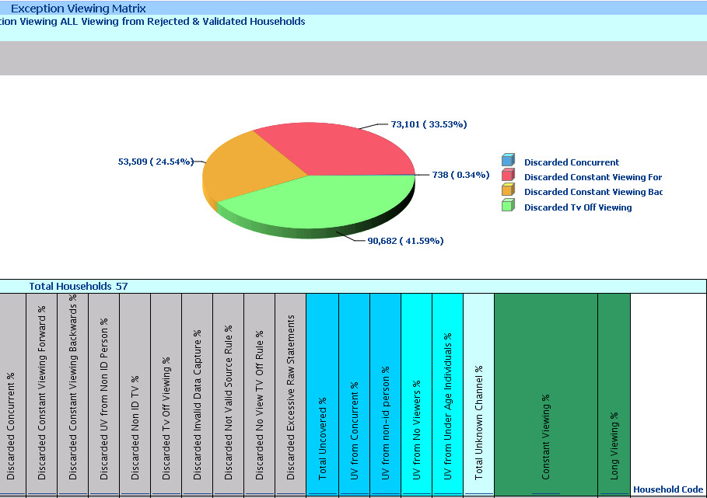

**Figure 2: Exception Viewing Pie Chart for Discarded Viewing.**

When clicking on any cell within the Exception Viewing Matrix, then the **Exception Viewing Summary by Household** will be opened and the exception selected will be highlighted in yellow (the entire line). Though there are a couple of variations, on the Uncovered Viewing and Unknown Channel:

* Total Uncovered %: The linked reports are (only if the percentage is > 0):

- Open Exception Viewing Summary by Household highlighting the exception selected with yellow.

-  Right Click from exception column cell to openUncovered Viewing Report, having the household preselected highlighted in yellow.

 -  Right Click from cell to open Uncovered Viewing Detail for the preselected household

* Total Unknown Channel %:

-  Open Exception Viewing Summary by Household highlighting the exception selected with yellow.

-   Right Click from cell to open the Unknown Channel Summary having the household preselected highlighted in yellow.

-   Right Click from cell to go to Unknown Channel Detail.

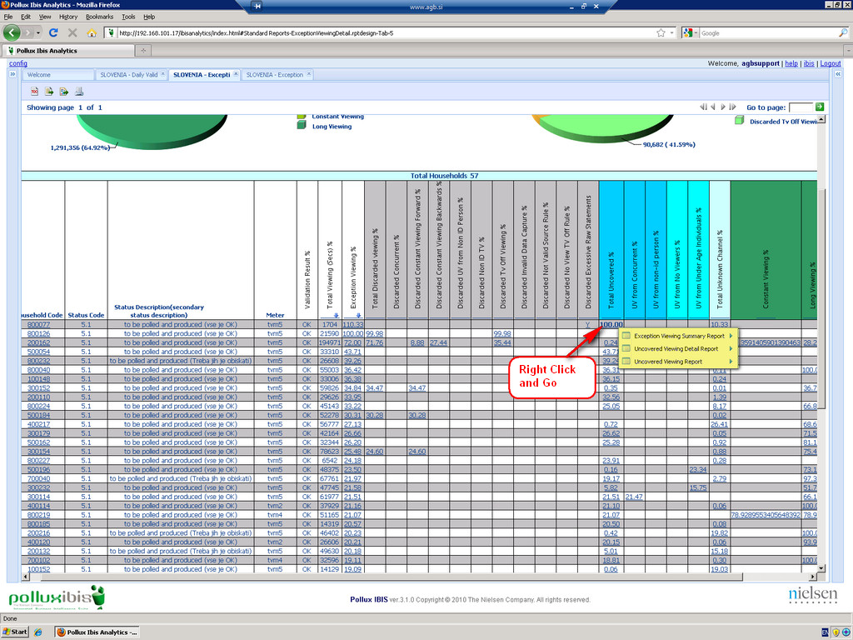

**Figure 3: Exception Viewing Report Main Page**

**Exception Viewing Summary** by Household follows a matrix format with information for 8 days ( as default but it is parametrical, if users want to expand their analysis), on each exception for a single home. Values are in absolute terms (seconds). The exceptions are grouped as per previous level.

The parameters to be transferred from Exception Viewing Matrix are:

•         Start Date = 8 days backwards

•         End Date = same day coming from Exception Viewing Matrix report

•         Household code

•         Clicked cell reference, highlighted in yellow

Variables or key elements included in the report:

•         Last contact date performed related to each exception. A configuration file is included as contact codes are different from country to country. Please contact [Pollux Product Manager](mailto:fatima.abreu@nielsen.com) to adjust the ETL process accordingly

•         Total Days Exception: It is the sum of the days the exception was bigger than 0 seconds. The count of days of exception is interrupted by: Not Polled, Off directory, Not to Produce, ALL REJECTS.

•         Average Exception (seconds): Average of the exception viewing only considering the days that the exception was bigger than 0.

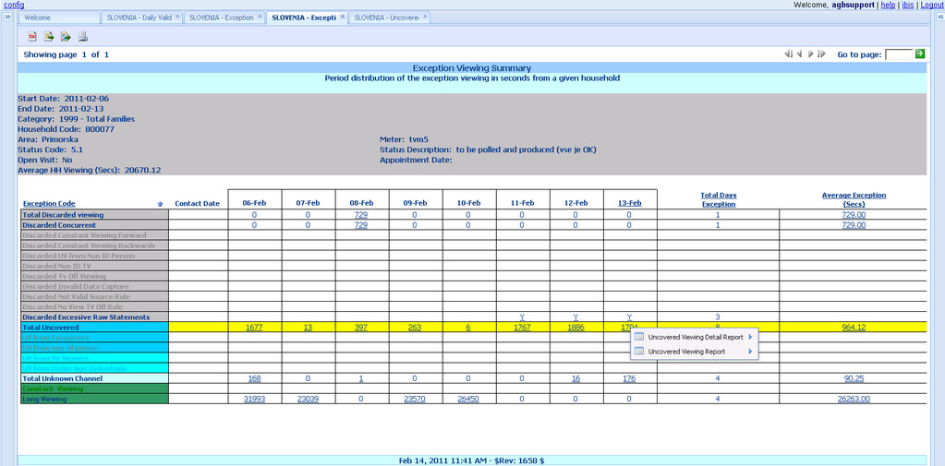

**Figure 4: Exception Viewing Summary**

* The report allows sorting of the information dynamically by:

                   - Total Days Exception

                   - Average Exception

                   - Last night or end date results.

**When any day cell at the Exception Viewing Summary by Household is clicked it will open the “Exception Viewing Detail” report displaying the details for that particular day. When any average cell at Exception Viewing Summary by Household is clicked then it will open the exception viewing detail report displaying the details for all days included in the period.**

**Exception Viewing Detail follows a similar format as per Uncovered Viewing Detail and Unknown Channel Detail reports. It provides information for a given day or range of days (8 days as default but it is parametrical, if users want to expand).**

**Values are in absolute terms (seconds) as well as relative format (percentage). The parameters to be transferred from Exception Viewing Detail are:**

* **Start Date = it is equal to end date or the same starting date of the range selected in “Exception Viewing Summary by Household”. This will depend upon the user’s selection.**
* **End Date = same day coming from Exception Viewing Matrix report.**
* **Household.**
* **Includes active members key demographics.**

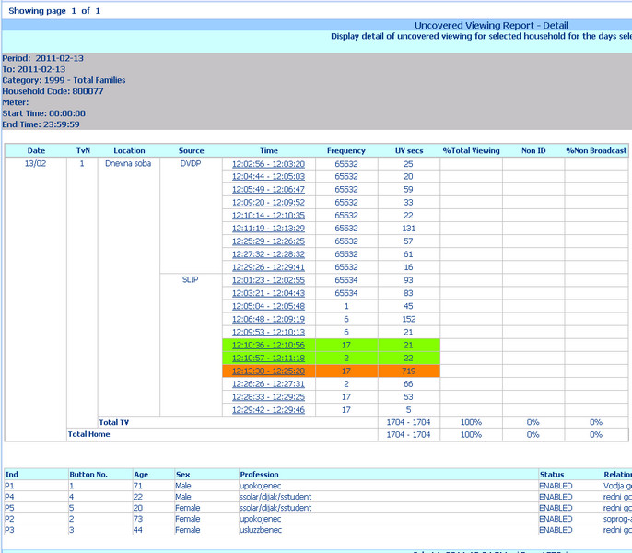

**Figure 5: Uncovered Viewing from Exception Viewing Detail**

**For the Exception Viewing Detail by Household the default sort is the same regardless the cell selected (clicked from). The exceptions will be grouped as per previous level, though:**

**•         Date followed by Exception List by TvN and Start/End Time. List of the same exception happening on different TvN**

**•         Allows user to sort dynamically the report by:**

**o  TvN**

**o   Source**

**o   Start / End Time**

**o   Duration**

**o   % Total Viewing**

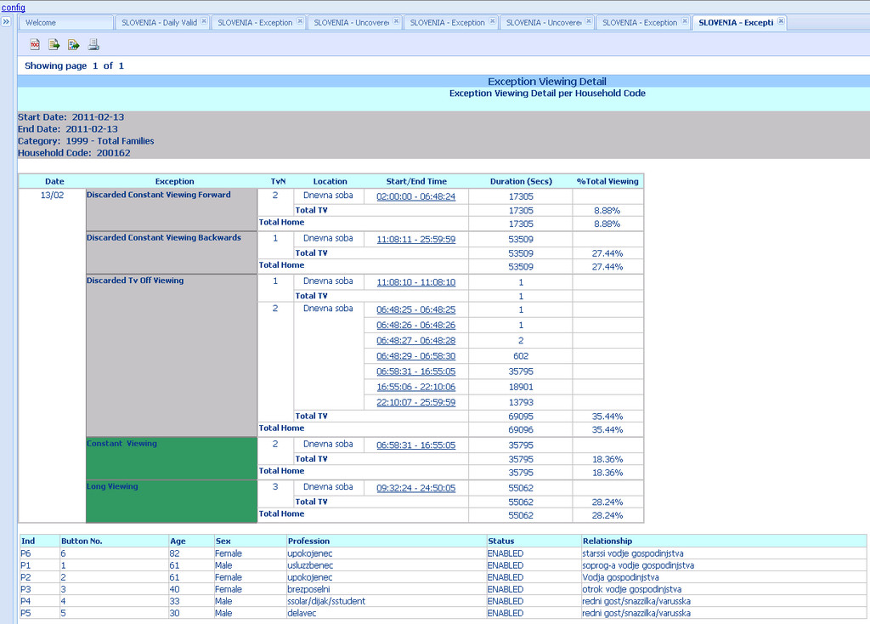

**Figure 6: Exception Viewing Report by Household**

**At “Panel Performance History” exceptions will be indicated with an “orange colour cell”, if more than one exception is present, Excessive Raw Statements will get the lowest priority (therefore not displayed).**

**At the tree menu the report is located under Validation directory.**

**18.5 Prepoll**

The objective of the Prepoll report is to have a list of Households that have failed the PrePoll phase and therefore won’t be polled.

It is composed by a main table listing all households that failed the PrePoll and the reason of the failure (indicated with Y – Yes). Also has a summary table that totalizes the quantity of households that failed PrePoll grouped by reason and meter type.

The report should be checked daily and households reported should be corrected to avoid losing them again. Remember that households that failed PrePoll won’t be polled or validated, therefore will not be included in the production.

Variables or key elements included in the report:

|  |  |
| --- | --- |
| **Field Name** | **Balloon** |
| Household Code | Panel Identification number in HHMaster |
| Meter | Meter type installed |
| Installation Date | Date the panel was installed (with at least 1 meter and 1 individual) |
| Status Code | Household Primary Status numeric code |
| Status Description | Household Primary Status Description and (Secondary Status description) |
| No TV Set | No TV Set with status "Monitored" or "Temporarily Unmonitored" on the Unit page - HHMaster and with a meter associated, therefore "No Monitored TV Sets" |
| Invalid Time Slot | The Time Slot field at Meter page - HHMaster. It should be set to "Even" or "Odd" to match the last digit of the meter serial number (Unitam and TVM5 meters don't follow this convention). |
| No Family Members | There is not a single individual with status "Enabled" on the Individual page - HHMaster |
| Diff Meter Type | When a Household has 2 or more different meter types installed or inserted on the Meter page - HHMaster, but the Pollux configuration (Poll2000.ini file) hasn't been updated or changed to allow its management |
| Invalid Area | When the Household code chosen for the family is out of range or not aligned with minimum - maximum number configured in File Maintenance - Area/subarea file |
| Invalid Button | When the active individuals don’t have a Button ID assigned - HHMaster - Individuals page and "Push Button" Management is activated. |

**Table 1: Report headings for Prepoll report.**

Conditional formatting ( please see section Configuration Tool - Data Integrity Tool )

* Any cell with a Yes (Y) should be highlighted with Orange to easily spot the problem or missing information. Configurable from "Data Integrity Tool". Active by default.
* If Meter type is not a Unitam or TVM5, then highlight cell in RED only for Invalid Time Slot column. Configurable from "Data Integrity Tool". Active by default.

Sorting (Main Table):

* By Household code
* Allow interactive sort on any column

Summary Table: Indicate the number of HHs that failed the PrePoll and total number of HHs on that meter type. Example: 7/515 from a total of 515 Households with TVM5 meter, 7 failed the PrePoll

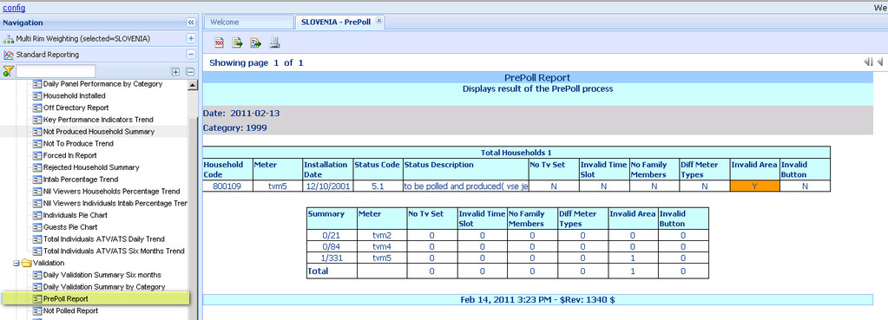

**Figure 1: Prepoll Report**

**18.6 Polling Statistics Report & Data Collection Results**

The aim of the Polling Statistics and Data Collection Report is to have an understanding of the performance of the polling process and to have a detailed list of all HHs on the different phases and results of the polling process.

Polling Statistic On Sample Report is considered the main report with several links to Data Collection Results (linked or detail).

Variables or key elements included in the report:

|  |  |
| --- | --- |
| **Field Name** | **Balloon** |
| Line ID | The line number used. |
| Meter Type | Meter type installed |
| Successful Calls | The number of the Successful Calls |
| Attempts | Number of times the line was used for polling/calling |
| Connect Time | Average of Connect Time (the connection time starts as soon as the modem starts calling the meter till the connection ends or fails |
| Unsuccessful Calls  Meter was NOT reached  (Problem w/ dialing) | The number of the Unsuccessful Calls where the failure is caused by problems with dialing |
| Unsuccessful Calls  Meter was reached (Problem w/ data exchange ) | The number of the Unsuccessful Calls where the failure is caused by problems with data exchange. The meters were able to answer the call but at a certain moment, the connection failed. |
| HHs Successfully  Polled/Called | The exact number of Households (Families) successfully polled/called. |
| % | The percentage (%) over the total number of polled families. |
| Attempts | The number of Attempts needed to successfully poll/call a Household. |
| Date | Date the polling/calling event happen |
| Timeslot | Each polling hour is divided in 2 slots: On the 1st half hour meters with serial numbers ending in "Even" will be attempted to poll. 2nd half hour for meters with serial numbers ending in "Odd" (Unitam and TVM5 meters don't follow this convention). |
| To be polled | Number of homes to be attempted to poll / call |
| Success. | Number of families that were successfully polled/called |
| Unsuccessful | Number of families that were polled and for which the polling was unsuccessful. |
| Not Attempt | Number of families that were scheduled for polling but there was no line available to attempt. |
| Max Attempt | Number of families that have reached the maximum number of possible attempts and were unsuccessfully polled/called. |

   Table 1: Report Headings Polling Statistics Report.

|  |  |
| --- | --- |
| **Field Name** | **Balloon** |
| Household Code | Panel Identification number in HHMaster |
| Line ID | Phone Line used in Pollux System to perform the polling/calling. The numeration (ID) of the lines indicates the meter type polled/called. Examples: codes from 1 to 49 refer to TVM2, codes starting with number 5 refer to 4900, and codes starting with number 40 refer to TVM4. |
| Meter Type | Meter type installed |
| Attempts | Progressive number of the attempts for the panel |
| Start Time | Time when the polling started. |
| Connect Time | Duration (in seconds) of the connection with the meter |
| No Statements | Number of statements downloaded from the meter. For 4900 meter type this figure refers to the file size. |
| Attempt Result | End result of the poll/call attempt |

                                             Table 2: Report Headings Data Collection Results.

•         Polling Statistic On Sample Report

o   Conditional formatting to be applied if number of unsuccessful attempts is greater than X% over successful calls performed on that specific line ID. It is configurable throughout "Data Integrity tool". Default 30%

o   If a line has 0 successful attempts then the cell will be highlighted in red. It is configurable through "Data Integrity tool". Default 0 attempts.

•         Data Collection Results

o   Homes with unsuccessful attempts should have the cells “Connect Time and N. Statements” highlighted in red. It should be configurable throughout "Data Integrity tool". Default 0 unsuccessful attempts.

o   Cell “N. Statements” where the number of statements is greater than X to indicate panel with excessive raw statements. Configurable from Data integrity Tool, default 2048 statements. Color Orange

Sorting:

•         Polling Statistic On Sample Report

o   Table 1: Line ID and Meter Type as default

o   Allow interactive sorting on all columns.

▪  Line ID; Meter Type; Successful Calls - Attempts; Successful Calls - Connect Time; Unsuccessful Calls Problems w/dialing- Attempts; Unsuccessful Calls Problems w/dialing - Connect Time; Unsuccessful Calls Problems w/Exchange- Attempts; Unsuccessful Calls Problems w/Exchange - Connect Time

•         Data Collection Results:

o   Default by Start Time

o   Allow interactive sorting on all columns.

▪  Household Code; Line ID; Meter Type; Attempts; Start Time; Connect Time; No Statements; Attempts Result

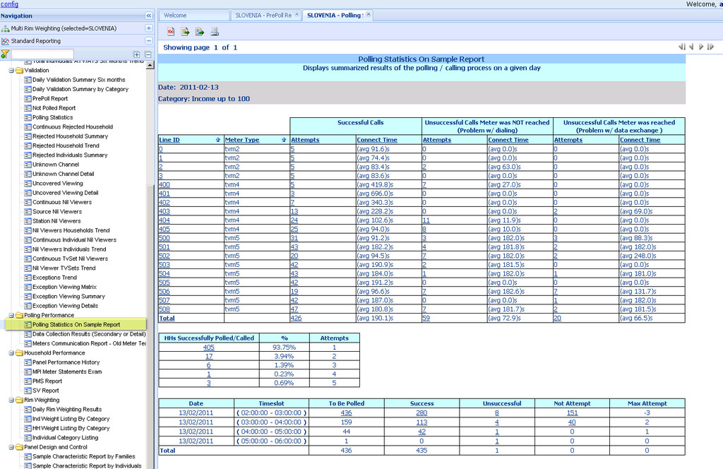

**Figure 1: Polling Statstics on Sample Report.**

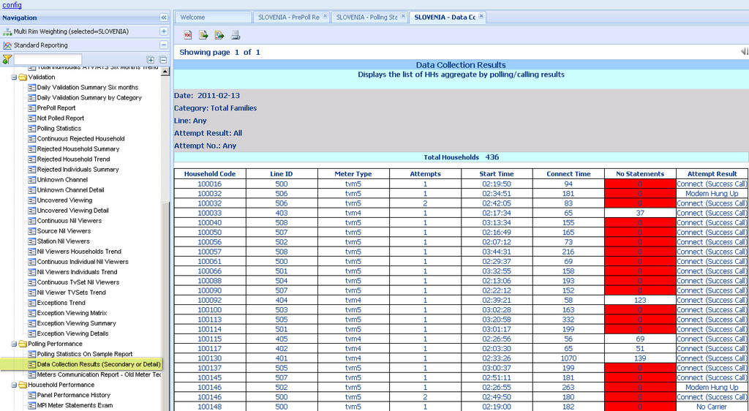

**Figure 2: Data Collection Results**

Conditional formatting ( please see section Configuration Tool - Data Integrity Tool )

**18.7 Meter Communication Report - Old Meter Technology**

The objective of the Meter Communication Report is to have a list of Households that have meter communication issues (between CDSU and MDU equivalent to TU and BU on modern meter technology). The report will list households that having successfully polled during 2 consecutive nights are still downloading statements registered more than 3 days, on the last night polling results.

Households that were not polled in previous days  to the polling day will naturally contain more than 1 day worth of statements that will not necessary indicate a meter communication problem, therefore are excluded from the initial filtering process.

The report should be checked daily and household reported should be corrected.

|  |  |
| --- | --- |
| **Field Name** | **Balloon** |
| Household Code | Panel Identification number in HHMaster |
| Meter | Meter type installed |
| Monitored TVs | Total monitored and temporarily not monitored TV sets in the house. Quality Status (QC Status) at the HHMaster - Unit page equal Monitored (0) and Temporarily Unmonitored (1) |
| Battery Level | Meter battery status. Only relevant for 4900 |
| `Power On | Presence of power (electricity) at the time of the polling / calling. |
| Statements Days  Downloaded | (day produced): number of days stored in the meter and collected during the last polling |
| Meter 1 | Meter Id and accumulated time (within the statements days downloaded) with power off (minutes). If the Meter is attached to the Main TV set, then it will be highlighted |
| CDSU | CDSU and accumulated time (within the statements days downloaded) with power off (minutes). Equivalent to TU or COMBOX on new meter technology |
| No Statements | Number of statements downloaded from the meter. For 4900 meter type this figure refers to the file size. |
| Time Drift | Time difference between polling server and the meter clock |

**Table 1: Report Heading Descriptions**

The report lists Households that:

* As default, have more than 3 days of “Statements Days Downloaded” and that have been successfully polled in the last 2 consecutive days.
* Households with “Low Battery” regardless the number of days “Statements Days Downloaded”. Then this should ignore, the filter on minimum days of polling
* Households with “Power Off” regardless “Statements Days Downloaded” Then this should ignore, the filter on minimum days of polling

Conditional formatting (please see sectionConfiguration Tool - Data Integrity Tool )

* To highlight "Power Off". Color orange. Customizable from "Data Integrity Tool". Active by default.
* To highlight "Low Battery Level". Color orange. Customizable from "Data Integrity Tool". Active by default.
* To highlight "Low Battery Level" and "Power Off" at the same time. Color Red. Customizable from "Data Integrity Tool". Active by default.
* To highlight "Statements Days Downloaded". Color red when more than 6 days. Customizable from "Data Integrity Tool". Active by default.
* To highlight "Statements Days Downloaded". Color orange between 3 to 5 days. Customizable from "Data Integrity Tool". Active by default.
* To indicate "Main TV Set" of HHs. Color green. Customizable from "Data Integrity Tool". Active by default. Main TV set is set from "Unit Page" HHMaster - field "Main TV" (Yes/No). If field is empty or null, set Unit 1 as "Main TV"

Sorting:

* Households with the highest number of “Statements Days Downloaded” on the top of the list
* Follow by (as second criteria):
* Households with “Low Battery” regardless “Statements Days Downloaded”
* Households with “Power Off” regardless “Statements Days Downloaded”
* Dynamic sort (on the fly) is allowed on any column.

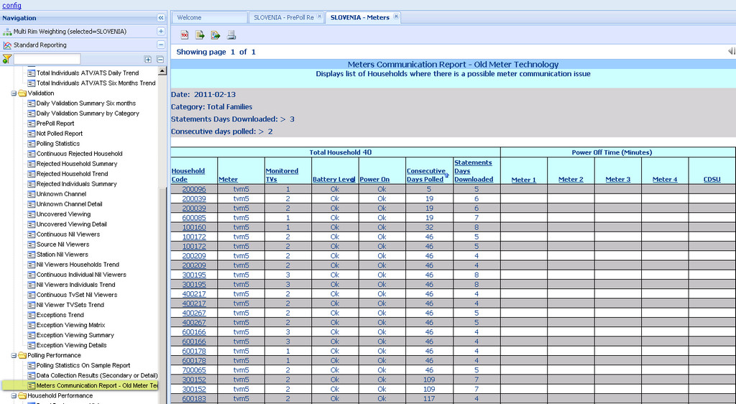

**Figure 1: Meter Communication Report**

**19. Logout**

